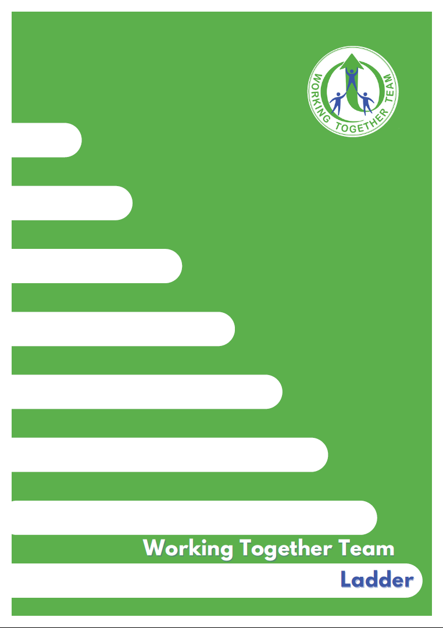

Contents | Page
Purpose of the WTT Ladder | 3
How the Ladder works | 4
Engaging with Families | 5
Foundation, Core and Bespoke WTT support | 6
Workshops for parents/carers | 7
WTT Ladder alongside a PSP (Pastoral Support Plan) | 8
Steps of the Ladder | 8
What if the setting feels the ladder is not improving outcomes for the child/young person (CYP)? | 9
Useful tools | 9 and 10
WTT Ladder template | 11 to 19

The purpose of the WTT Ladder

The WTT Ladder works as part of the One Lincolnshire approach, working within the Lincolnshire High Needs Strategy and alongside the SEND Workforce Development platform.
WTT, through Gosberton House Academy are Lincolnshire’s Autism Education Trust Licensed Training Hub for Early Years, Schools and Post-16.
The team are an NAS Accredited Advanced Status service advocating best practice for autistic children/young people (CYP) in Lincolnshire mainstream settings.

The team are very knowledgeable about best practice in supporting autistic pupils in mainstream education. They are committed to seeking to overcome obstacles to autistic pupils being included in mainstream schools. They recognise the importance of empowering and skilling up staff in mainstream schools.
Stephen Dedridge- Head of Autism Accreditation (South)

The WTT Ladder is underpinned by the social model of inclusion. We are supporting setting to think of; difference not deficit, understand behaviour as communication and be curious as to what that means, use a strengths-based approach, know and understand the unique individual and shape provision around them to enable participation in learning and a positive self-identity enabling them to thrive and achieve the best possible outcomes in school and life.

The setting should have reasonable adjustments in place to structural policies e.g. behaviour, exclusions uniform and homework, for CYP with autism/social communication differences as with other Special Educational Needs (SEN).

The WTT Ladder is an opportunity to reflect on and enhance existing practice and create equity for all learners. Accessing support from WTT, relies on engagement and commitment from the whole setting.

The WTT Ladder is a process which should be initiated as part of the Graduated Approach to address SEN arising within autism/social communication differences.
The pupil should be on the settings SEN register.

Having needs within autism/social communication differences does not mean a setting must initiate the ladder. The setting should be addressing individual differences through their graduated approach e.g. use of a One-Page profile, accessing training to upskill the setting staff, ensuring individual targets address social communication differences and document how adults will support and adapt their practice to address those.



How the Ladder works

The WTT Ladder is a tool to support settings to address the needs of CYP with autism/social communication differences where the nature of the environment, expectations, demands and relationships are having a negative impact on their academic progress and/or their socio-emotional health and wellbeing.

Engagement with WTT through the Foundation, Core and Bespoke training workshops and support at whole setting level, builds the steps of the Ladder to upskill professionals in understanding the unique strengths and differences of the CYP and identifying positive approaches to support. It is the responsibility of the setting to reflect and update their SEN provision at each stage of the Ladder and send it into WTT for further feedback.

A WTT online Helpline will run via Microsoft Teams each Friday morning for any general queries about the Ladder process. The link to the online helpline will be sent to SENCOs at the start of each term but can also be acquired through emailing outeach@gosberton-house.linc.sch.uk.

All Lincolnshire mainstream settings have an allocated WTT outreach teacher and it is essential for the team to be liaising with one key person from the settings SEND department to share information. Your WTT outreach teacher can signpost to appropriate next steps via the Ladder. To find out which WTT outreach teacher covers your setting, please use the email above.

Engaging Families in the WTT Ladder process

As part of the Graduated approach to SEN, families should be involved in the WTT Ladder discussions and provide their consent for data and information to be shared with WTT. A factsheet for Parents/Carers, about the WTT service, is available on the WTT website. www.wtt.org.uk

We know that autistic CYP often have a different presentation between environments so it is important to have the holistic picture. Therefore, it is extremely beneficial for families and the young person if appropriate, as experts on their youngster, to be involved at all steps of the Ladder so we are working in true collaboration in the best interests of the CYP

Best practice will be collaborative, seeking to understand the CYP’s strengths and differences from a range of perspectives and target next steps from that understanding of the unique individual, identifying how the adults can shape their practice around the pupil to enable success.

One-Page Profiles/Pupil Passports are a powerful way to share that understanding with all of those working with and around the pupil. These should be a working document. Further explanation on creating a one-page profile can be found in the Useful Tools section below.

An effective Ladder meeting should be a constructive planning session that focuses on the positives and seeks to understand the challenges for the pupil from his/her perspective.

The WTT Ladder should be viewed as a way to upskill both professionals and families to design a bespoke and differentiated approach to both academic and socio-emotional learning, from the CYP’s starting point.

Foundation, Core and Bespoke WTT support for settings

WTT offer a robust and externally validated programme of specialist training and workshops to build capacity, confidence and competence in understanding and meeting the needs of autistic pupils, through a joined-up approach, enabling early intervention and prevention of escalating needs.

It is essential that the setting have completed Autism Education Trust Making Sense of Autism, at the relevant phase, for ALL staff within the last 3 years in order to utilise the WTT Ladder.

Details of central training can be found on the WTT website and updates will be emailed to settings. Settings can also request any of the below, for their setting or Trust through liaising with their WTT Outreach teacher.

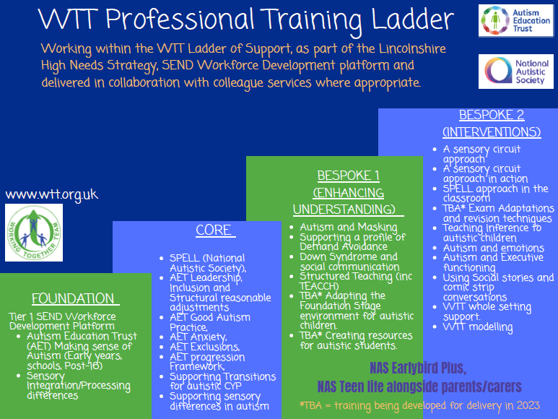

Workshops for parents/carers

It is essential that we provide our families with opportunities to further understand autism and approaches they can utilise outside of school.

Details of central workshop events can be found on the WTT website and updates will be emailed to settings. Settings can also request sessions for parents/carers within their setting community through liaising with their WTT Outreach teacher.

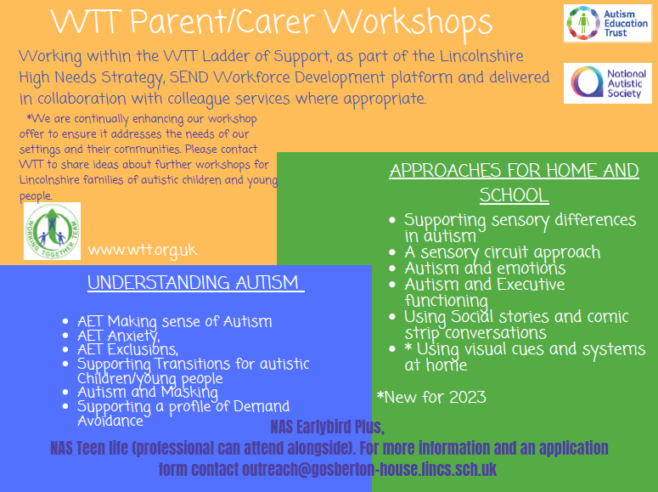

WTT Ladder alongside a PSP (Pastoral Support Plan)

There are often co-occurring conditions associated with autism.
As a setting you may also be using a Pastoral support plan
The WTT Ladder is designed so that information can be transferred from one to the other, however the WTT Ladder will ask to reflect specifically through an autism lens as you progress through.

Steps of the Ladder

The WTT Ladder should be completed by a member of staff within the settings SEND department and in collaboration with key staff around the CYP and their family. The pupil should be on the SEN register.
The Ladder works as part of the Graduated Approach- each step is a cycle of assess, plan, do review

- Key details and parental consent

- Ladder Step 1- Foundation and Core Training

- Ladder Step 2- Core and Bespoke Training

- Ladder Step 3- WTT Consultation

- Ladder Step 4- Setting seeking Bespoke specialist WTT support (based on previous steps)

Suggested timescale for each Ladder step is 6-8 weeks. WTT will feedback during each step and provide recommendations. There should be a period of implementation and assessment of impact before completing the next step in the Ladder.

What if the setting feels the ladder is not improving outcomes for the child?

At each step, your setting will reflect on the targets agreed through the Ladder and the strategies used by adults in the setting to enable success.
If there is no/limited progress for the pupil, WTT will recommend you refine the target further, use different strategies or we may signpost to resources or training that will address those needs. We may suggest modelling of an intervention to support consistent and effective delivery.
We may ask you to think about co-occurring conditions and needs as you work through the Ladder and also clarify the consistency of approach within the environment.
Consistency of sharing information amongst all key people collaborating around the CYP is essential.
If the Ladder is still not impacting positively then you would escalate through the Ladder and via your Graduated Approach to find ways forward.

Tools to support the Ladder

Valuing SEND https://professionals.lincolnshire.gov.uk/special-educational-needs-disabilites/valuing-send
Lincolnshire Inclusion toolkit https://professionals.lincolnshire.gov.uk/homepage/55/send-inclusion-toolkit
AET Competencies -individual practice, AET standards -setting practice. AET Progression framework-assessment/reference tool https://www.autismeducationtrust.org.uk/framework-documents
Sensory profile -schools/families https://www.wtt.org.uk/page/?title=Sensory+Processing+%26amp%3B+Integration&pid=26
How to One-page profile- https://www.wtt.org.uk/page/?title=One+Page+Profiles&pid=77

Pupil voice ideas
- Through a direct chat with the CYP about what they like and don’t like, what they are good at and enjoy, what is more difficult, what they want you to know about them.
- Email, story, letter from the CYP
- A picture, painting or art work that depicts their feelings and emotions
- A video or multi-media approach sharing information (PowerPoint presentation etc)
- An interview sent to us – and/or a collection of information from peers/siblings or other family members

WTT Ladder

- The WTT Ladder is an opportunity to reflect on and enhance existing practice and create equity for all learners. Accessing support from WTT, relies on engagement and commitment from the whole setting.

Pupil Details
- Pupil name:
- Prefers to be known as:
- Date of birth:
- Setting:
- Ladder completed by:
- Email address:
- Date consent given/updated:
- Have the setting contacted Ask SALL before starting the ladder? Y/N | Yes/ No
- If no, please provide a brief reason:
- SEN register level: | SEN support/EHC NA request pending-has been submitted/EHC Plan in place
- Gender/identity:
- Preferred pronouns:
- Diagnosis:
- Please highlight as appropriate: Safeguarding concerns, Child in Need, TAC, ESCO, Looked after Child (LAC), Post-LAC
- Other services currently involved:

- Reason for starting the Ladder:
- Background history of pupil:
E.g. anything that will impact on current development/presentation etc

Consent
Working Together Team is a service commissioned by Lincolnshire County Council and relevant
information, including personal data, may be shared with our commissioner.
WTT documents may be requested by SEND at Lincolnshire County Council, Community paediatricians and other agencies/services involved with supporting your child or young person.
By signing, you are consenting to Working Together Team working with the educational setting to support your child or young person. You are also consenting to us sharing that information with other agencies involved in that support to help everyone work collaboratively in the best interests of the child/young person.

Signed: Parent/guardian__________________________________ Date___________

Signed: SENCo _________________________________________Date___________

Signed: Young Person ____________________________________ Date___________
(if appropriate)

Signed : Headteacher____________________________________ Date___________

Timeline of engagement (to be completed by WTT)
Ladder Step 1

Ladder Step 1 records the start of your engagement with WTT support. Once you complete all of the boxes in step 1, send the form to outreach@gosberton-house.lincs.sch.uk for WTT feedback and to be recorded as starting the Ladder.

Ladder Step 1
Foundation and Core WTT training offer accessed (highlight as appropriate) :
- AET modules- Making Sense of Autism, Progression Framework, Anxiety, Good Autism Practice, Exclusions, Leadership, Inclusion and Structural Reasonable Adjustments
- SEND Workforce Development module on Sensory Integration and processing differences.
- Preparing for transition, SPELL (NAS), Supporting sensory differences
Dates and who attended:

Impact of training

Which strategies have you implemented from the Foundation and Core WTT training offer for your whole school community? | What impact have these had for your pupil?
E.g. Reasonable adjustments to school routines, procedures and policies, working with individuals’ strengths and interests, use of visuals, adding structure, sensory adaptations, social interactions/friendships, adapting language and identifying and then addressing barriers to engagement/participation.

Pupil voice:
It is essential to listen to the voice of the child.

See Useful Tools for suggestions
Parent/carer voice:
e.g. routines, eating, self-care, going out, special interests, toileting, emotions etc

Current targets and strategies:

What is working well?

What are we worried about? (what is not working well?)

What does success look like for the CYP? (What needs to happen?)

Success statements | Scaling (0 there are no skills towards this at this time, 10 success achieved consistently)

Previous/ current involvement from (with dates):

Setting feel confident in ………

We need to develop confidence in ………

*Include VSEND Readiness radar image here

Send the form to outreach@gosberton-house.lincs.sch.uk. WTT will respond within 5 working days.
WTT feedback:

Date returned:

Ladder Step 2 records the review of the support you have implemented in step 1 and any feedback/suggestions given by WTT . All suggestions should be actioned and reviewed before progressing through the ladder.

Ladder Step 2
Bespoke WTT training offer accessed: (please highlight as appropriate)
Sensory Circuit approach, Social Stories and Comic Strip Conversations, Supporting a profile of Demand Avoidance, , Supporting CYP with an Internal presentation of Autism (masking), Autism and Executive functioning, Autism and emotions, Teaching Inference in Autism, Structured teaching approach, Adapting the Foundation stage environment for autistic children (for 2023), Creating resources for autistic students (for 2023) and Exam Adaptations for autistic students (for 2023), Visits to specialist NAS Accredited setting to observe best practice. (Sensory circuit approach/SPELL), WTT whole setting support, WTT modelling of strategies
Dates and who attended/was involved:

Impact of training

Which strategies have you implemented from the Bespoke WTT training offer for your whole school community? | What impact have these had for your pupil?

Updated Pupil voice:

Updated Parent/Carer voice:

Review of targets on individual plan:

What is working well?

What are we worried about? (what is not working well?)

What does success look like for the CYP? (What needs to happen?)

Success statements | Scaling (0 there are no skills towards this at this time, 10 success achieved consistently)

Other agencies involved in support (inc updates):

Updated Confidence in meeting need
Could be shown via :
Updated statements, readiness radar from VSEND, AET Standards etc

AET Progression framework Baseline %
Setting to select and complete at least 1 relevant section for the pupil as a baseline.
 | NYD | D | E | G
Communication and interaction

Are you using any other assessment tools?
E.g. PIVATS (which and please share evidence of progress)

Send the form to outreach@gosberton-house.lincs.sch.uk. You will receive feedback within 5 working days
WTT feedback:

Date returned:

Ladder Step 3-Where WTT see that you have actioned previous suggestion, have engaged with the Core and bespoke training offers and implemented practice in your setting, you will be invited to have a thorough verbal consultation with WTT. Parents/Carers should be invited where possible.

Ladder Step 3
Verbal consultation with WTT
Date: Consultation with:
SEN register: SEN support / EHC NA request in/planned/ EHCP in place

Diagnosis?
Updated Pupil voice:
Updated Parent/carer voice:
Review of targets from Ladder Step 2
What is working well?

What are we worried about? (what is not working well?)

What does success look like for the CYP? (What needs to happen?)

Success statements | Scaling (0 there are no skills towards this at this time, 10 success achieved consistently)

Other agencies involved in support:
Updated Confidence in meeting need
Could be shown via:
readiness radar from VSEND
AET Standards etc

AET Progression framework Baseline %
Setting to update at least 1 relevant section for the pupil as a baseline.
 | NYD | D | E | G
Communication and interaction

Are you using any other assessment tools?
E.g. PIVATS (which and please share evidence of progress)

Send the form to outreach@gosberton-house.lincs.sch.uk. You will receive feedback within 5 working days
WTT feedback:

Date returned:

Ladder Step 4- A review of advice and discussion from Step 3. Once complete, please send this into WTT for moderation where the most appropriate way forward will be identified.

Ladder Step 4-request to escalate to bespoke personalised WTT support

Ladder Step 4
Reflect and action advice from verbal consultation with WTT
Date:
Pupil voice:

Targets on individual plan:

What is working well?

What are we worried about? (what is not working well?)

What does success look like for the CYP? (What needs to happen?)

Success statements | Scaling (0 there are no skills towards this at this time, 10 success achieved consistently)

Other agencies involved in support;
Confidence in meeting need

AET Progression framework- review

 |  | D | E | G
Communication and interaction

- Setting are now seeking bespoke specialist support from WTT to address this CYP’s needs. The ladder of support will be reviewed by WTT to further advise and provide next steps for support.

Send the form to outreach@gosberton-house.lincs.sch.uk. You will receive feedback within 5 working days
WTT feedback:

Date returned:

*WTT will add additional information here as appropriate

