


Partnerships for Inclusion of Neurodiversity in Schools (PINS) Menu of Support

This menu is to support schools and local partnerships in identifying the most appropriate evidence-informed support for the setting.

- Schools will make choices from this menu with the support of the project team who will give guidance on the length, type and content of the support as appropriate for the setting. These may take the form of packages of support around specific topics or domains, including initial training sessions and follow-up support or coaching, within the allotted time frame for support.
- The number of different topics that can be delivered within the five days will depend on the length of the interventions selected.
- The support given will focus on a whole school approach. Delivery of the support may include training for all schools, single school staff teams, MATs, smaller groups with relevant professionals tailored to develop capacity in the school setting/ MAT/ Federation setting , considering the local resources available.
- This project covers the full range of neurodiversity, and any training and support provided will cover a range of needs, Being needs- rather than diagnosis-led, it also covers children without a formal diagnosis.

Domain 1  (indicative link to Ofsted inspection framework) |  | Topic | Descriptor for schools | Offer and content overview
Leadership, Culture and Values (Leadership and management) | 1.Understanding the needs of neurodiverse students |  | Support for schools to better understand the needs of neurodiverse children as a basis to develop and implement universal  and targeted strategies within the school environment. | PINS WTT 2 Day Developing Inclusive Leadership conference.  [ in person; and recorded for delivery with the support of schools’ named lead PINS practitioner]  Content overview  This 2 day, in person conference is a bespoke package from the WTT PINS team, including the AET Developing Inclusive Leadership module which includes:  - Understanding the need for change to improve outcomes for CYP  - Enabling inclusion and systemic good practice  - Educational policy and legislation  - Vision, strategy and actions.  - Developing an autism inclusive culture  - Pupil voice  - Reflection and action planning time  We will also explore what it means to Belong in school and how we can ensure that our policies, procedures and co-production enable needs-led inclusion for all.  PINS AET Making Sense of Autism module CPD - 90 minutes  [Teams/whole school/ MAT]  Content overview  - How autism affects pupils in school  - Recognising a pupil’s individual strengths and differences  - Identifying barriers to learning for autistic pupils  - Understanding of what “reasonable adjustments” need to be made to support an autistic pupil in your setting.  PINS AET Autism & Inclusion module CPD - 2 x 2 hours  [ twilight/Teams/whole school, MAT]  Content overview  - The exclusion process – lawful and unlawful exclusions and avoiding disability discrimination  - The inclusion process - Identifying underlying reasons for exclusion and making reasonable adjustments to promote inclusion  PINS AET Early Years Making Sense of Autism module CPD - 1 x 90 mins  [ twilight/Teams/whole school, MAT]  Content overview  - How autism affects children in Early years  - Recognising individuals strengths and differences  - Identifying barriers to learning  - Understanding what reasonable adjustments need to be made to support an autistic child in your setting.  PINS AET Making sense of Neurodivergence - 90 mins  [ twilight/Teams/whole school, MAT]  Content overview  - Approaching neurodiversity as a difference  - Strengths and differences for neurodivergent pupils and creating enabling environments.  - Neurodivergent perspectives  - Reasonable adjustments to support  PINS WTT Autism & ADHD - 2 hours  [ twilight/Teams/whole school, MAT]  Content overview  - Consider the complexities of supporting CYPs with a dual diagnosis  - Share best practice and experiences with others  - Explore approaches for success

Domain 1  (indicative link to Ofsted inspection framework) |  | Topic |  | Descriptor for schools | Indicative content
 | Leadership, Culture and Values (Leadership and management) | 2.School leadership and  culture | Supporting schools to promote and develop an inclusive whole school culture, ensuring they have appropriate skills to engage with neurodiverse children.  Providing support to schools to articulate a plan that embodies a whole school approach to neurodiversity.  Enabling leadership teams to understand the value of reviewing their policies and guidance to support inclusivity in their schools.  Supporting SLT, governing bodies, SENCOs and whole school staff to sustainably create inclusive schools, including influencing teaching practices and curriculum development.  Supporting schools to hear the voice of neurodiverse children and their parents and carers, ensuring that they are fully involved in co-production, including in the development of new policies and a more inclusive culture in school. |  |  | AET The Progression Framework module CPD-2hours[ twilight/Teams/whole school, MAT]  Content overview  This training will support you in:  - Becoming familiar with the key features and  content of the AET Progression Framework.  - Knowing how to use the AET Progression  Framework to identify priorities and set  learning intentions for individuals.  - Knowing how to use the AET Progression  Framework to provide evidence of progress.

Domain 1  (indicative link to Ofsted inspection framework) | Topic | Descriptor for schools | Indicative content
Leadership, Culture and Values (Leadership and management) | 3. Working and co-producing  change with  parents and carers | Supporting schools to develop their work with parents and carers and the wider community to support a culture of inclusivity, and to build relationships and trust.  Developing a “team around the school” approach – where parents and carers, health, education and children themselves, working together to support a neurodiversity-friendly learning environment where children have their needs met. | WTT PINS can offer Leading Parent Partnership Award overview of expectations and what ‘best practice’ looks like. Please request this from your PINS lead practitioner  LPCF led  Signpost to LPCF website offer, week of SEND, targeted and bespoke support packages supported by PINS lead practitioner  Identifying parent/carer support needs and signposting to relevant organisations and support.  Developing meaningful parent/carer surveys and feedback opportunities for all parents/carers with children on the SEND register, including offering adapted/supported opportunities to give feedback where appropriate.  LPCF- supporting parents and carers to develop peer networks of support, and developing the capacity of the parent carer body to engage and participate in school life alongside teaching staff, such as through the work of the local Parent Carer Forum.  Developing culture and processes to support co-production at an individual level with parents and carers and children around their provision and adaptations.  Supporting school leaders and teaching staff to engage confidently with parents and carers.

Domain 2  (indicative link to Ofsted inspection framework) |  | Topic |  | Descriptor for schools |  | Indicative content
 | Mental Health (Personal development) |  | 4.Neurodiversity and mental health |  | Promoting positive wellbeing for all students and staff, including those who are neurodiverse.  Supporting schools to recognise and respond appropriately to the emotional wellbeing and mental health needs of all children particularly those who are neurodiverse. | Mental Health Support Teams, Healthy Minds Lincolnshire, CAMHS  Lincolnshire Partnership NHS Foundation Trust  Training offer at  Healthy Minds - Resource Hub  Click to download Healthy Minds Lincolnshire Intervention Toolkit for Professionals.  Click to play the 'Graded Approach' presentation  The Body Image Information Pack  Content coverage  Anxious Feelings Adverse Childhood Experiences Emotional Regulation Low Mood Mental Health Awareness Self-esteem Self-harm School Based Anxiety/Using a Graded Approach  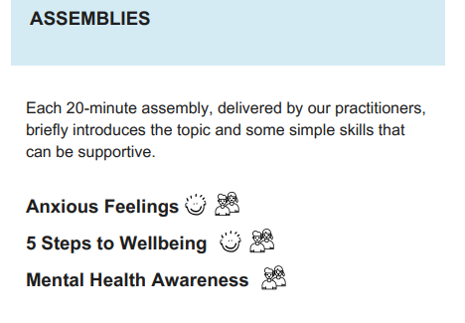  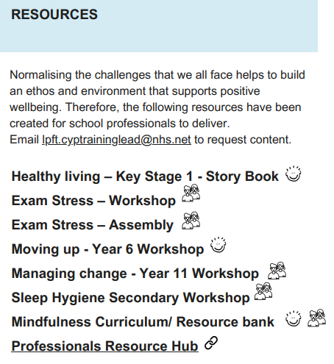  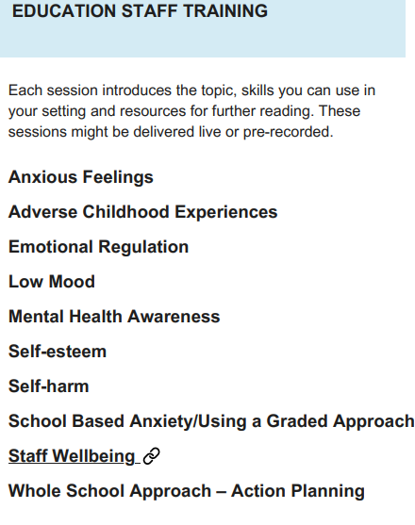  New to Lincolnshire Lumi Nova  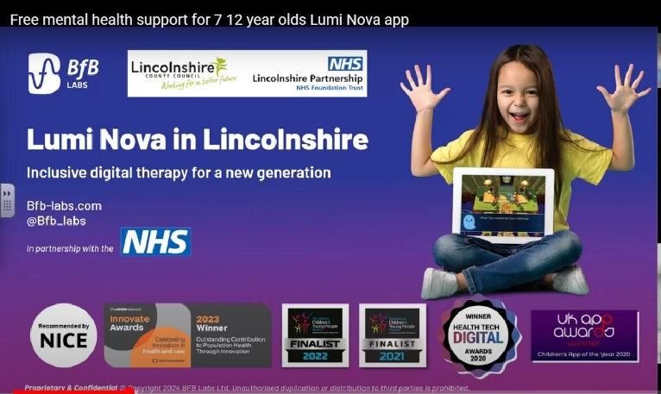

Domain 2  (indicative link to Ofsted inspection framework) | Topic |  | Descriptor for schools | Indicative content
Mental Health (Personal development) |  |  | Supporting schools to identify and consider other factors (including co-occurring conditions) that may adversely impact on the emotional wellbeing and mental health of neurodiverse children, including speech and language deficits.  Understanding and supporting staff with the emotional impact of responding to behaviours that challenge. | WTT/PINS Autism & emotional development – 2hrs  [ twilight/Teams/whole school, MAT]  Content overview  - To be aware of the correlation between sensory processing and emotional recognition and regulation  - To explore emotional recognition in self and others  - To understand the steps towards being able to manage emotions effectively.  - To explore resources and tools that can help develop emotional regulation  WTT/ PINS Lincs Neurodivergency & Masking - 3hrs  [ twilight/Teams/whole school, MAT]  Content overview  - Understanding masking behaviours in neurodiverse children.  - To identify key differences for those with an internal presentation of Autism  - To explore adaptations and strategies for support  WTT/ PINS Lincs Autism & Eating challenges 2-3 hrs  [ twilight/Teams/whole school, MAT]  Content overview  Increasing awareness of the prevalence of sensitivity around food and eating difficulties (including ARFID) for neurodiverse children and provide support to plan strategies to support children with this within the school environment.  LPFT Nurturing the wellbeing of children and young people  Full day  Content overview  What is EWB, 5 steps to wellbeing, WSA, Bullying, wellbeing on a universal level, Identifying emotional wellbeing, conversation tools, trauma informed practice, ACES, Behaviour as communication, staff wellbeing, (Secondary risk planning), window of tolerance, Whole class Ideas  Booked via Eventbrite.  Nurturing the Wellbeing of Children & Young People | Eventbrite  LPFT Building Resilient Foundations  Virtual 3 hours  Content overview  What is emotional wellbeing?, 5 steps to wellbeing, 5 area model, Reflection on language, behaviour as communication, hand model of the brain, window of tolerance, promoting regulation, risk exploration and safety planning, Maslow, Different wellbeing presentations, overview of local services.  Book via Lincs2Learn

Domain 2  (indicative link to Ofsted inspection framework) | Topic |  | Descriptor for schools | Indicative content
Mental Health (Personal development) |  | 4. Neurodiversity and mental health continued |  | AET Autism & Anxiety module CPD - 2hrs  [ twilight/Teams/whole school, MAT]  Content overview  Exploring common factors in the academic environment that can increase anxiety for neurodiverse children, how that anxiety might be expressed and reasonable adjustments that can be made to prevent and reduce a pupil’s anxiety  EBSA Toolkit-self audit, risk screening, interventions  https://www.lincolnshire.gov.uk/support-education/emotional-based-school-avoidance-ebsa/2  The EBSA Pathway is a graduated response (follows an assess, plan, do, review cycle) that is focused on:  - meaningful and robust early intervention through effective whole school systems.  - clear understanding of individual needs and contexts.  - collaborative, person-centred working with parent and carers and the child or young person.  Professionals  Guide to Supporting your Emotional Wellbeing  Healthy Minds Lincolnshire have created a ‘Guide to Supporting your Emotional Wellbeing for Professionals’ package to support your own emotional wellbeing. Within this guide we will explore the ‘5 Ways to Wellbeing’ where we will share evidence-based ideas that are applicable to people from all walks of life.  Click to play the Guide to Supporting your Emotional Wellbeing Toolkit.

Domain 3  (indicative link to Ofsted inspection framework) | Topic |  |  | Descriptor for schools | Indicative content
Readiness to Learn (Quality of education; Behaviour and attitudes) |  | 5. Wellbeing and readiness to  learn | Supporting schools to work together with parents/carers to support children holistically. |  | Developing consistent approaches from home and school to ensure neurodiverse children are happy, healthy, supported and ready to learn and able to engage in the classroom, including:  - managing emotions  - behaviour  - boundaries/demands  - executive functioning  - organisation  - speech, language, and communication skills  - transitions, including the transition between home and school  Supporting schools to understand the challenges around sleep which can impact students with neurodiversity, how this affects learning, and strategies to support this in the classroom.  Increasing awareness of the prevalence of sensitivity around food and challenges with eating for neurodiverse children and provide support to plan strategies to support children with this within the school environment.

Domain 3  (indicative link to Ofsted inspection framework) | Topic |  |  | Descriptor for schools | Indicative content
Readiness to Learn (Quality of education; Behaviour and attitudes) |  | 6. Attendance and absence, including emotionally based school avoidance | Supporting schools to understand the importance of attendance and that absence – including emotionally based school avoidance (EBSA) – is almost always a symptom of wider circumstances.  Developing a school-wide approach to increasing attendance and supporting schools to work sensitively with families to put in place additional support where necessary to enable children to access full-time education, ensuring the approach aligns with the ‘Working together to improve school attendance’ guidance. |  | hyperlink for WTT/PINS training offer  WTT Autism & Executive functioning  [ twilight/Teams/whole school, MAT]  Content overview  - What is executive functioning and what are the key areas that might be different in neurodivergent pupils. How do these impact access to learning and how can we adapt and adjust to support effectively.  EEBSA Pathway  https://www.lincolnshire.gov.uk/support-education/emotional-based-school-avoidance-ebsa/4  EBSA Toolkit  https://professionals.lincolnshire.gov.uk/ebsa-pathway/ebsa-toolkit  Whole School Approach tools  https://professionals.lincolnshire.gov.uk/downloads/download/240/ebsa-toolkit  Pupil Re-Integration Team

Domain 3  (indicative link to Ofsted inspection framework) | Topic |  | Descriptor for schools | Indicative content
Readiness to Learn (Quality of education; Behaviour and attitudes) |  | 7. Approaches to behaviour | Supporting schools to consider what reasonable adjustments may need to be made to their behaviour policy for neurodiverse children, ensuring all policies align with the Behaviour in Schools guidance. | Training Registration (family-action.org.uk)  BOSS ADHD Awareness module CPD- 1x 1hr 20mins  [Teams]  Improve knowledge and understanding of ADHD and gain skills and strategies to support children with ADHD in the classroom  BOSS Attachment Aware and trauma responsive practice module CPD- 1x1hr 20mins  [Teams]  Improve knowledge around attachment and trauma and provide attachment aware and trauma informed strategies to be used in the classroom  BOSS Profile of Demand Avoidance module CPD- 1x1hr 20mins  [Teams]  Improve knowledge and understanding of a Profile of Demand Avoidance and gain skills and strategies to support children in the classroom  BOSS Regulation and De-escalation module CPD – 1x1hr 20mins  Improve understanding of regulation and de-escalation and share strategies to support regulation and de-escalation in the classroom  BOSS Sleep Awareness Workshop – 2 Sessions 2x 1hr 20mins  [Teams]  Improve knowledge and understanding of the impact of sleep and gain skills and strategies to support SEND children with sleep issues.  BOSS Supporting pupils with SEND- module CPD – 1x1hr 20mins  [Teams]  This session looks at identifying pupils with SEND and strategies to support  BOSS Transition Nursery to Primary- module CPD- 1hr 20mins  [Teams]  Plan for a successful transition. Gain strategies and share ideas with participating schools  BOSS Understanding behaviour as a communication- module 1hr 20mins  [Teams]  Improve understanding of what behaviour might be telling us, and gain skills and strategies to support children in the classroom  Register for our virtual training here : Virtual Training Registration  View our resources here: Lincolnshire BOSS Resources  BOSS Input January 25 dates to be confirmed  AET Early Years Developing Play module CPD - 1 x 2.5hrs  [ twilight/Teams/whole school, MAT]  Content overview  - Understand how the three areas of difference impact on the development of play skills.  - Understand the importance of all adults working together to support the child to develop play skills.  - Develop knowledge of how to support autistic children to develop play skills.  - Create and deliver a plan to ensure progress in play skills, which includes consideration of how to remove barriers and make reasonable adjustments.  AET Early Years Developing Toileting module CPD - 1 x 2.5hrs  [ twilight/Teams/whole school, MAT]  Content overview  - To understand the differences in autistic children that may impact independent toileting.  - To understand the importance of working with others to support children to develop independent toileting skills.  - To develop knowledge of how to support children to achieve toileting independence.  - To plan and deliver a Child-Centred Toileting Plan, that will ensure children make progress in developing toileting skills.  AET Transitions 2.5 hours  [ twilight/Teams/whole school, MAT]  Content overview  - Be able to identify examples of school transitions and understand whether these might be described as macro or micro.  - Understand the particular demands of transitions across the Primary and Secondary school phases for all children but especially autistic children and young people.  - Be able to identify why autistic children and young people require specific enhanced support to reduce the potentially negative impact of transitions on their education and wellbeing.  - Develop knowledge of the strategies that can be used to support autistic children and young people with transitions in schools.  - Be able to apply knowledge of transition support strategies.  - Plan how to utilise knowledge and understanding within professional practice

Domain 3  (indicative link to Ofsted inspection framework) | Topic | Descriptor for schools | Indicative content
Readiness to Learn (Quality of education; Behaviour and attitudes) | 7. Approaches to behaviour continued |  | WTT Autism & SPELL NAS programme 12 hours CPD  [ twilight/Teams/whole school, MAT]  Content Overview  - Supporting schools to consider factors which may be barriers to neurodiverse children in engaging in learning/academic work.  - Providing strategies to support neurodiverse children to engage with and access learning within school, including supporting school staff to develop a toolkit of alternative approaches to teaching core skills, e.g. phonics and basic maths skills, and ensuring schools are identifying and sharing best practice within their staff.  Graduated Approach Briefing July 24 professionals.lincolnshire.gov.uk  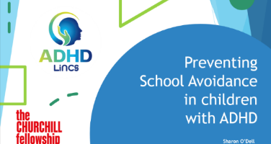  Powerpoint presentation Liaise, ADHD,  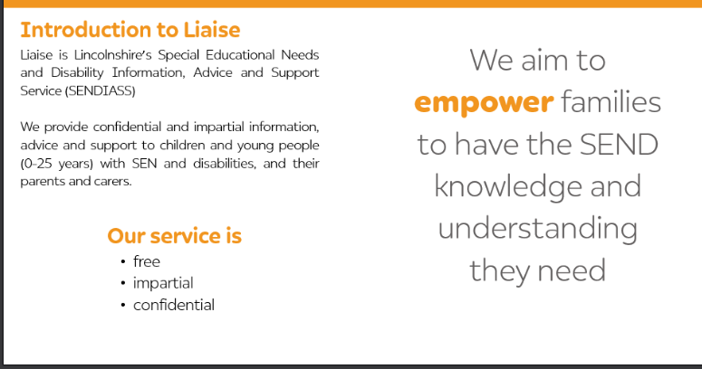

Domain 4  (indicative link to Ofsted inspection framework) | Topic |  | Descriptor for schools | Indicative content
Teaching and Learning (Quality of education; Behaviour and attitudes) |  | 8. Skills for Learning | Supporting school staff to better understand common learning styles of neurodiverse children.  Developing the skills required to support neurodiverse children to better engage in learning and adjusting teaching practice to facilitate their engagement. | - Developing an understanding of a range of cognitive functions and learning styles, understanding how these can be different for neurodiverse children and taking a person-centred needs approach in supporting them.  - Supporting schools in developing neurodiverse children’s self-esteem through a successful experience of learning, e.g. by meeting different learning styles and needs in the classroom.  - Supporting schools to identify motivation for learning and to engage in a strengths-based approach.  LHNT.lincschildrenstherapyservice@nhs.net.  Understanding Handwriting Development-practical strategies for the classroom

Domain 5  (indicative link to Ofsted inspection framework) | Topic | Descriptor for schools | Indicative content
Environment (Quality of education; Behaviour and attitudes) | 9. The sensory and physical environment | Supporting schools to better understand the impact of the sensory and physical environment on neurodiverse children and their ability to engage in education.  Undertaking a sensory and physical environmental audit to ensure that the school environment meets the needs of neurodiverse children. | PINS/WTT Using the Positive Sensory Profile  Duration 1.5 hours  Approach- twilights, Teams, and then MAT/school follow up  Content overview  - Supporting school staff to increase their understanding of sensory and physical needs in all children, and to consider how sensory input influences behaviour and affects alertness and engagement in education.  - Undertaking a professional audit of the current school environment, including parent/carer and pupil voice, supported by resources to ensure that schools can continue to re-assess the environment themselves.  - Enhancing teachers’ understanding of the impact of sensory stimuli and physical classroom environment on children’s ability to regulate and learn.  - Supporting teachers to make changes to the classroom environment in order to enhance children’s learning experience and regulation.  PINS/WTT Using a Sensory circuit approach  Duration1-1.5 hours  Content overview  Video/live observations

Domain 6  (indicative link to Ofsted inspection framework) | Topic |  | Descriptor for schools | Indicative content
Communication  (Quality of education; Behaviour and attitudes) |  | 10. Social communication & peer relationships | Supporting schools to better understand social communication challenges for neurodiverse children and how this can impact their school experience.  Implementing consistent strategies to support neurodiverse children and their neurotypical peers with their social communication and peer relationships. | PINS/WTT Developing Social knowledge in neurodivergent pupils  Duration 2hrs  Approach- twilights, Teams, and then MAT/school follow up  Content overview  Exploring what is meant by social communication, and the factors that can affect social communication for neurodiverse children.  Supporting schools to develop confidence and competence in delivering strategies within the classroom that support inclusion of neurodiversity.  Recognising that neurodiverse children may have a wide range of needs, and identifying which of these might be met by universal support or adapted teaching strategies, and when to access specialist support.  Supporting schools to develop clear plans regarding peer acceptance and celebrating neurodiversity and inclusion.  SLCN-ECLIPS  Universal offer, pre-recorded General SLCN and DLD General Awareness training General SLCN and DLD general awareness training: 'The most common disorder no-one has ever heard of.' This session aims to help you understand SLCN better. It provides practical advice to support students in your setting.  https://www.lincolnshire.gov.uk/directory-record/63813/specialist-speech-and-language-training  Sensory Processing Difficulties website supports CYP with SPD, and includes a wealth of supporting resources and information, and is supported by an optional two and half hour-long virtual workshop with a Behavioural Specialist. It is intended to upskill and educate parents, carers, and professionals. The programme is available to Lincolnshire parents and carers and professionals and delivered six times a year with approximately 50 attendees at each workshop and evaluates very positively. For 2024 we have extended the workshop to allow parents and carers to share their own experience and have commissioned two additional bolt-on workshops on Pathological Demand Avoidance and Burnout in Neurodiversity for families who have attended the initial session.  Sensory processing difficulties :: Lincolnshire Children's Therapy Services (lincolnshirechildrenstherapyservices.nhs.uk)

Domain 6  (indicative link to Ofsted inspection framework) | Topic |  | Descriptor for schools | Indicative content
Communication  (Quality of education; Behaviour and attitudes) |  | 11. The language environment: classroom language for learning | Supporting schools to better understand how classroom language can support learning for neurodiverse children and their ability to engage in education.  Undertaking a school language audit to ensure that the spoken environment meets the needs of neurodiverse children. | On site visit conducted by PINS/WTT team member using AET resources

Domain 5  (indicative link to Ofsted inspection framework) |  | Topic |  | Descriptor for schools |  | Indicative content
 | Communication  (Quality of education; Behaviour and attitudes) |  | 11. The language environment: classroom language for learning continued |  |  | WTT Using social stories and comic strip conversations  Approach- twilights, Teams, and then MAT/school follow up  Content overview  - To think about differences in social understanding for autistic children and young people  - To understand the purpose and principles of a social story  - To understand how a comic strip conversation can be used.  Lincolnshire Local Offer SEND Inclusion Toolkit Strategies and Interventions Speech, Language and Communication description of levels, strategies and resources  Social Communication Needs resources and strategies

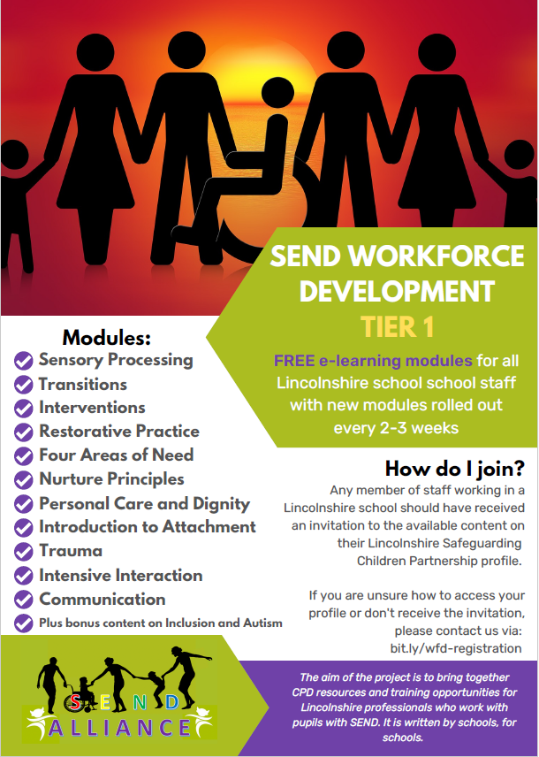
Awareness raising of what is available in Lincs e.g.Graduated Approach briefings?
https://professionals.lincolnshire.gov.uk/homepage/54/graduated-approach-briefings#

EBSA pathway
https://www.lincolnshire.gov.uk/support-education/emotional-based-school-avoidance-ebsa/2

MHST
Healthy Minds

LCHS-Children’s Therapy services- sensory processing
https://www.lincolnshirechildrenstherapyservices.nhs.uk/neurodevelopmental-difficulties/sensory-processing-difficulties

Ask Sall information links – Professional resources (lincolnshire.gov.uk)
Here you can find information and links to a range of other services including ESCO, TAC, PRT, STT, WTT to name but a few.
It is here you can also access a link to both the Valuing SEND tool and the SEND Inclusion Toolkit.

