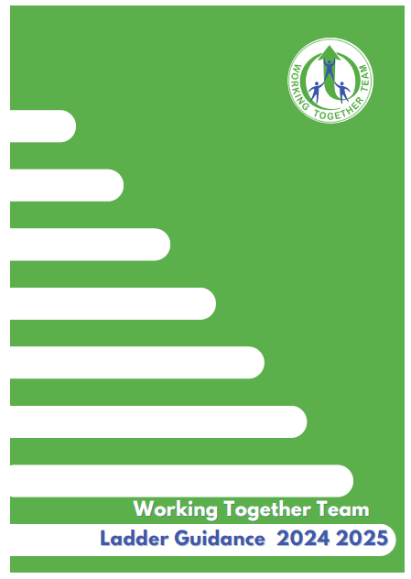

Contents | Page
Purpose of the WTT Ladder | 3
How the Ladder works | 4
Engaging with Families | 5
Foundation, Core and Bespoke WTT support | 6
Workshops for parents/carers | 7
WTT Ladder alongside a PSP (Pastoral Support Plan) or EBSA | 8
Steps of the Ladder | 8
What if the setting feels the ladder is not improving outcomes for the child/young person (CYP)? | 9
Useful tools | 9 and 10

The purpose of the WTT Ladder

The WTT Ladder works as part of the One Lincolnshire approach, working within the Lincolnshire High Needs Strategy and alongside the SEND Workforce Development platform.
WTT, through Gosberton House Academy are Lincolnshire’s Autism Education Trust Licensed Training Hub for Early Years, Schools and Post-16.
The team are an NAS Accredited Advanced Status service advocating best practice for autistic children/young people (CYP) in Lincolnshire mainstream settings.

The team are very knowledgeable about best practice in supporting autistic pupils in mainstream education. They are committed to seeking to overcome obstacles to autistic pupils being included in mainstream schools. They recognise the importance of empowering and skilling up staff in mainstream schools.
Stephen Dedridge- Head of Autism Accreditation (South)

The WTT Ladder is underpinned by the social model of inclusion. We are supporting setting to think of; difference not deficit, understand behaviour as communication and be curious as to what that means, use a strengths-based approach, know and understand the unique individual and shape provision around them to enable participation in learning and a positive self-identity enabling them to thrive and achieve the best possible outcomes in school and life.

The setting should have reasonable adjustments in place to structural policies e.g. behaviour, exclusions uniform and homework, for CYP with autism/social communication differences as with other Special Educational Needs (SEN).

The WTT Ladder is an opportunity to reflect on and enhance existing practice and create equity for all learners. Accessing support from WTT, relies on engagement and commitment from the whole setting.

The WTT Ladder is a process which should be initiated as part of the Graduated Approach to address SEN arising within autism/social communication differences.
The pupil should be on the settings SEN register.

Having needs within autism/social communication differences does not mean a setting must initiate the ladder. The setting should be addressing individual differences through their graduated approach e.g. use of a One-Page profile, accessing training to upskill the setting staff, ensuring individual targets address social communication differences and document how adults will support and adapt their practice to address those.



How the Ladder works

The WTT Ladder is a tool to support settings to address the needs of CYP with autism/social communication differences where the nature of the environment, expectations, demands and relationships are having a negative impact on their academic progress and/or their socio-emotional health and wellbeing.

Training First
Engagement with WTT through the Foundation, Core and Bespoke training workshops and support at whole setting level, builds the steps of the Ladder to upskill professionals in understanding the unique strengths and differences of the CYP and identifying positive approaches to support. The training record now sits as a separate document for the whole setting which WTT can update to show training provided to school or attended as part of the central offer. It is the responsibility of the setting to reflect and update their SEN provision at each stage of the Ladder and send it into WTT for further feedback.

A WTT online Helpline will run via Microsoft Teams each Friday morning for any general queries about the Ladder process from mainstream schools. The link to the online helpline will be sent to SENCOs at the start of each term but can also be acquired through emailing outreach@gosberton-house.linc.sch.uk. You can also contact your WTT outreach teacher to arrange a conversation with them at a time that is convenient for you both.

All Lincolnshire mainstream settings have an allocated WTT outreach teacher and it is essential for the team to be liaising with one key person from the settings SEND department to share information. Your WTT outreach teacher can signpost to appropriate next steps via the Ladder. To find out which WTT outreach teacher covers your setting, please use the email above.

The WTT offer for independent, specialist settings and Early years settings is through our Central training offer which can be found on our website www.wtt.org.uk

Engaging Families in the WTT Ladder process

As part of the Graduated approach to SEN, families should be involved in the WTT Ladder discussions and provide their consent for data and information to be shared with WTT. A factsheet for Parents/Carers, about the WTT service, is available on the WTT website. www.wtt.org.uk

We know that autistic CYP often have a different presentation between environments so it is important to have the holistic picture. Therefore, it is extremely beneficial for families and the young person if appropriate, as experts on their youngster, to be involved at all steps of the Ladder so we are working in true collaboration in the best interests of the CYP

Best practice will be collaborative, seeking to understand the CYP’s strengths and differences from a range of perspectives and target next steps from that understanding of the unique individual, identifying how the adults can shape their practice around the pupil to enable success.

One-Page Profiles/Pupil Passports are a powerful way to share that understanding with all of those working with and around the pupil. These should be a working document. Further explanation on creating a one-page profile can be found in the Tools to Support section below.

An effective Ladder meeting should be a constructive planning session that focuses on the positives and seeks to understand the challenges for the pupil from his/her perspective.

The WTT Ladder should be viewed as a way to upskill both professionals and families to design a bespoke and differentiated approach to both academic and socio-emotional learning, from the CYP’s starting point. It is schools responsibility to share ladder updates with the parents/carers, however if they do approach us directly for the latest information and there is no safeguarding reason to restrict sharing of that information then we will need to send them the latest version.

Foundation, Core and Bespoke WTT support for settings

WTT offer a robust and externally validated programme of specialist training and workshops to build capacity, confidence and competence in understanding and meeting the needs of autistic pupils, through a joined-up approach, enabling early intervention and prevention of escalating needs.

It is essential that the setting have completed Autism Education Trust Making Sense of Autism (or an alternative WTT whole school training), at the relevant phase, for ALL staff within the last 3 years in order to utilise the WTT Ladder.

Details of central training can be found on the WTT website https://www.wtt.org.uk/calendar/?calid=4,5,6&pid=10&viewid=1 and updates will be emailed to settings. Settings can also request any of the below, for their setting or Trust through liaising with their WTT Outreach teacher.

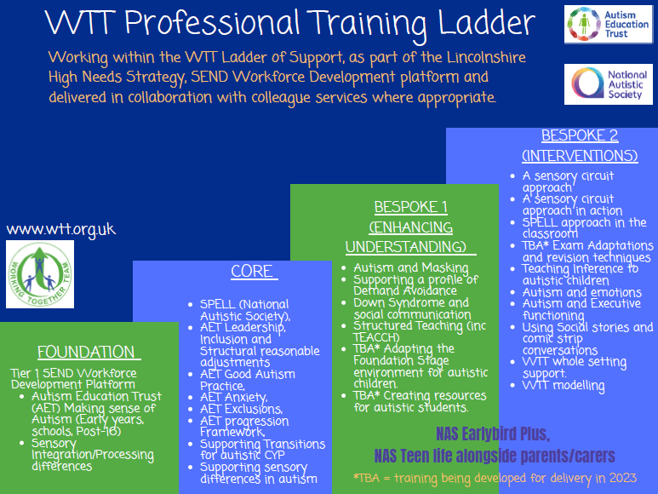

Update visual here and for website

Workshops for parents/carers

It is essential that we provide our families with opportunities to further understand autism and approaches they can utilise outside of school.

Details of central workshop events can be found on the WTT website and updates will be emailed to settings. Settings can also request sessions for parents/carers within their setting community through liaising with their WTT Outreach teacher.

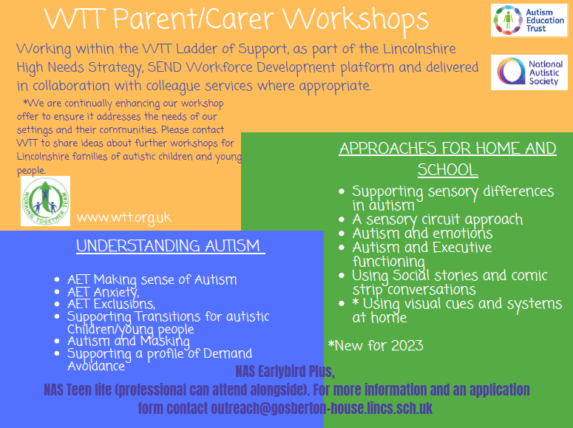

Update visual here and for website

WTT Ladder alongside a PSP (Pastoral Support Plan) or EBSA pathway

There are often co-occurring conditions associated with autism.
As a setting you may also be using a Pastoral support plan or the EBSA pathway
The WTT Ladder is designed so that information can be transferred from one to the other, however the WTT Ladder will ask to reflect specifically through an autism lens as you progress through.

Steps of the Ladder

The WTT Ladder should be completed by a member of staff within the settings SEND department and in collaboration with key staff around the CYP and their family. The pupil should be on the SEN register.
The Ladder works as part of the Graduated Approach- each step is a cycle of assess, plan, do review

- Key details and parental consent

- Ladder Step 1- Foundation, Core and/or Bespoke Training

- Ladder Step 2- WTT Consultation (plus continued use and reflection on relevant training)

- Ladder Step 3- Setting seeking Bespoke specialist WTT support (based on previous steps)

Suggested timescale for each Ladder step is 6-8 weeks. WTT will feedback during each step and provide support strategies to implement and reflect upon. There should be a period of implementation and assessment of impact before completing the next step in the Ladder.

What if the setting feels the ladder is not improving outcomes for the child or young person ?

At each step, your setting will reflect on the targets agreed through the Ladder and the strategies used by adults in the setting to enable success.
If there is no/limited progress for the pupil, WTT will recommend you refine the target further, use different strategies or we may signpost to resources or training that will address those needs. We may suggest modelling of an intervention to support consistent and effective delivery.
We may ask you to think about co-occurring conditions and needs as you work through the Ladder and also clarify the consistency of approach within the environment.
Consistency of sharing information amongst all key people collaborating around the CYP is essential.
If the Ladder is still not impacting positively then you would escalate through the Ladder and via your Graduated Approach to find ways forward.

Tools to support the Ladder

- Valuing SEND
https://professionals.lincolnshire.gov.uk/special-educational-needs-disabilites/valuing-send

- Lincolnshire Inclusion toolkit
https://professionals.lincolnshire.gov.uk/homepage/55/send-inclusion-toolkit

- AET Competencies -individual practice, AET standards -setting practice. AET Progression framework-assessment/reference tool
https://www.autismeducationtrust.org.uk/framework-documents

- Positive Sensory profiling Tool -schools/families
https://www.wtt.org.uk/page/?title=Sensory+Processing+%26amp%3B+Integration&pid=26

- How to One-page profile
https://www.wtt.org.uk/page/?title=One+Page+Profiles&pid=77

Ideas for gaining Pupil perspective

- If a pupil is non-speaking, you can gather information through careful observation, reading reports and assessments by other professionals, and by talking to other people who know them.
What are they drawn to? How do they engage with the areas of the classroom?
- Through a direct chat with the CYP about what they like and don’t like, what they are good at and enjoy, what is more difficult, what they want you to know about them.
- Email, story, letter from the CYP
- A picture, painting or art work that depicts their feelings and emotions
- A video or multi-media approach sharing information (PowerPoint presentation etc)
- An interview sent to us – and/or a collection of information from peers/siblings or other family members

