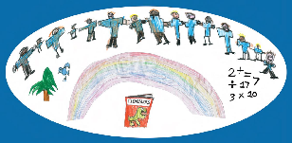



Creating a

Positive

Sensory Profile

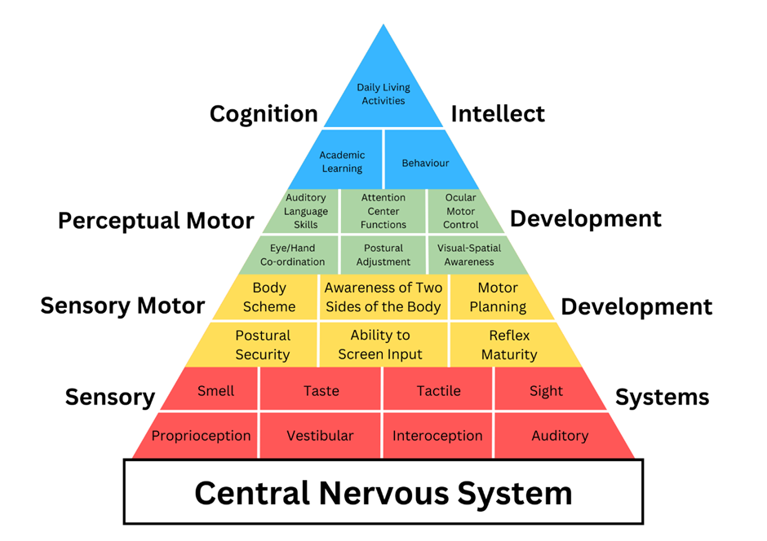

The Pyramid of Learning (Trott & Taylor)
The development and regulation of the sensory systems are the foundations necessary for attention, engagement, focus and learning


Positive Sensory profile for: Date:

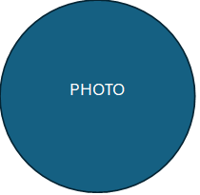
Sensory Preferences:

Resources:

Positive Sensory Programme:

Target Priorities:

Sensory Challenges:

Reasonable adjustments:

Any other information:

This 1-page profile is a living document and should be reviewed regularly as part of the Graduated Approach, or if there is a significant change in behaviour/presentation. Strategies and interventions should be implemented consistently for a period of 4-6 weeks. Our research at WTT indicates that this time frame typically allows for observable impact.

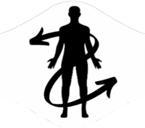
The Proprioceptive System
Observed sensory based behaviours  Use a code such as S= School, P= Parent, C= Carer to show who has observed this sensory behaviour | Always | Often | Some  times | Rarely | Never
Moves slowly, appears lethargic and tires easily
Avoids activities that provides resistance
Prefers to be without shoes
Doesn’t like tight fitting clothes/ Likes tight fitting clothes
Becomes anxious with unpredictable movement (e.g. PE) or frequent movement (e.g. from carpet to chair)
Difficulty with tasks requiring fine/gross motor skills
Often on the perimeter of the classroom/playground
Moves in quick bursts of activity rather than sustained effort
Uses inappropriate force on an object (too much or too little)
Poor gait when walking
Difficulty imitating, planning and sequencing physical movement
Walks on toes/walks heavily
Self-injurious behaviours- pinching /biting/ head banging
Plays roughly with other children
Clumsy/bumps into things
Doesn’t extend arms to break fall
Kicks heels against the floor/chair
Seeks frequent movement breaks
Leans on objects/people for stability
Loves jumping/ wrestling/ crashing activities
Presses too hard or too light when colouring/writing
Pulling/ twisting/ Chews on clothes/Objects
Grinds teeth/ cracks knuckles
Looks at hands whilst writing or feet whilst riding a bike
Accidently breaks objects frequently
Seeks tight hugs and squishing activities/ positions

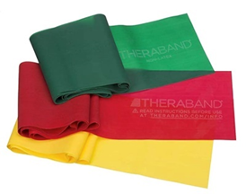
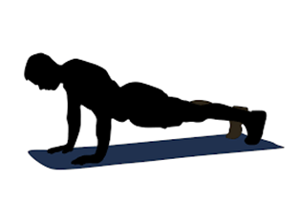
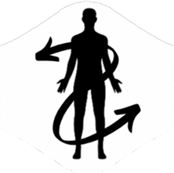
For the home
- Accessing soft play
- Tighter fitting clothing
- Weighted blankets (time limited)
- Provide access to crunchy/chewy foods/vibrating toothbrush
- ‘Hot dog game’- CYP lays on stomach, arms legs and back rubbed then snuggled tightly in a blanket
- Swimming
- Carry a weighted rucksack- calming
- Chewy snacks
Interventions
- Access to daily sensory motor activities
- Access to gym ball for additional rhythmical input
- Heavy work – deep pressure (for some students, every 2hrs)
- Yoga to stretch and relax muscles
- Teaching self-deep pressure techniques (self-joint compressions)
- Floating balloon games
- Beanbag target practice
- Playdoh
Strategies
- Drink from a water bottle e.g. with a straw
- Removal of shoes/Barefoot play and when necessary
- Hand exercises before handwriting
- Weighted supports (time limited), e.g. blankets, lap pads, vests, wrists/ankle weights, pencils/pens
- Weighted toys (can also be used during sustained periods of seating)
- Provide a range of regulating resources e.g. items to squeeze, stretch, twist, bite or chew
- Velcro strip stuck under the desk to rub
- Alternative seating- Hokki stool, Zuma chair, wiggle/wobble cushions, gym ball
- Movement/sensory breaks
  - Heavy muscles work e.g. carrying, pushing and pulling, climbing, squeezing/hugging activities e.g. wrap in blanket, self-hug, rolling
  - Resistance activities e.g. Therabands
- Allow additional toilet breaks and/or switching seats
Strategies to try

The Vestibular System

Observed sensory based behaviours  Use a code such as S= School, P= Parent, C= Carer to show who has observed this sensory behaviour | Always | Often | Some  times | Rarely | Never
Avoids activities that require both feet off the ground, fears being ‘off balance’ e.g. PE lessons
Unsettled (motion sickness) after movement experience
Holds head upright while leaning back or bending over
Poor negotiation over uneven ground
Frequently stumbles, trips, falls
Hesitation on steps/equipment
May try to control or manipulate events to avoid stressful sensations
Often seeking physical support from adults during movement
Dislikes sudden movement
Dislikes changes of body position
Uses slower movements
Seems to be thrill seekers/no sense of danger. E.g. climbing, jumping from high places
W sitting on the floor
Difficulty sitting ‘still’
Constantly moving/loves spinning/being upside down
Muscles and joints seem to be too soft/floppy
Slumps/leans in chair- poor balance
Prefers to lay down
Rocks self or moves head back and forth/side to side to maintain attention
Becomes over-excited after movement activity
Actions do not cross midline of body
Difficulty following a moving object with head/body
Trouble holding head up whilst sitting
Self-spins for sustained periods without getting dizzy

Strategies
- For a hyper-sensitive vestibular system limit unnecessary movement, allow additional time to move around, transitions and avoid activities where feet are off the ground
- Movement/sensory breaks – involving balancing’
  - Activities involving moving the head from side to side; turning, rotating, spinning, skipping, rocking, being upside down, rolling and tumbling
  - Activities involving moving the head up and down; jumping/bouncing, gym ball, star jumps, trampoline
- Alternative seating- Hokki stool, Zuma chair, wiggle/wobble cushions, gym ball, standing desk
- Allow the young person to maintain the position they are safe and regulated in, to complete adult led expectations (e.g. standing while working)
- Limited number of children or additional space for CYP during PE activities
- During PE consider alternatives to tumbling, running and jumping activities
- Allow CYP to hold on during balance activities
- When seated in the classroom, encourage feet to be placed on the ground
- Allow CYP to switch seats if/when needed
Strategies to try

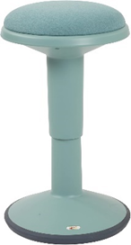
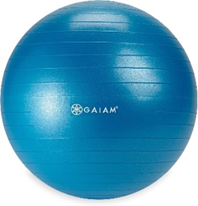
Intervention
- Access to daily sensory circuits – to include use of monkey bars / trim trail / ‘log rolling’
- Yoga to stretch and relax muscles
- Scooter boards to navigate obstacles
For the home
- Wobble board to develop core stability
- Activities involving moving the head from side to side/up and down; turning, rotating, spinning, skipping, rocking, being upside down, rolling and tumbling, jumping (trampoline/bed), swinging, dancing to music, play park
- For motion/travel sickness gradually increase length of journey
- Extra-curricular gymnastics
- Use of stairs rather than escalators
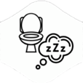
The Interoceptive System

Observed sensory based behaviours  Use a code such as S= School, P= Parent, C= Carer to show who has observed this sensory behaviour | Always | Often | Some  times | Rarely | Never
Doesn’t feel hungry/ Doesn’t recognise feeling full up
Is constantly drinking always seeming thirsty/ Unaware of being thirsty
Unaware of feeling too hot/too cold
Unaware of full bladder and/or bowel/ over responsive sensation for toilet needs
Can often seem lethargic/ tires easily
Unaware when they are hurt unless they can see it
Under responsive/ heightened response to pain/itch
Unaware of increased heart rate
Does not recognise when tired/ heighted response to feeling tired
Delayed response to feeling unwell
Alexithymia (emotional and physical wires getting crossed e.g. they may know they feel cold but do not recognise this as a possible sign of fear/anxiety)
Ideas to support interoceptive differences
- Teaching clear routines for self-care and independence tasks (visually supported)
- Labelling physical signs/e.g. ‘I can see that you are hot because…’
- Encourage the CYP focus on their own body to identify clues to different emotions
- Personalised visual cues and prompts e.g. emotions, schedules and instructions
- Use proprioceptive and vestibular strategies to facilitate a calm/alert state
- Mindfulness and relaxation activities incorporating deep breathing – e.g. Yoga
- Use proprioceptive and vestibular support strategies to assist calm/alert state
- Providing resources and books related to emotions and feelings
- Where appropriate, support CYP to use personalised scaling to communicate & self-regulate

Emotional responses that may indicate differences in interoceptive sensory processing

Observed sensory based behaviours  Use a code such as S= School, P= Parent, C= Carer to show who has observed this sensory behaviour | Always | Often | Some times | Rarely | Never
Impulsive, appears to act before thinking
Prone to distressed behaviours
Displays ‘aggression’ towards self/ others
Finds changes in routines difficult to manage
Finds it difficult to follow verbal instructions/ direction
Gives up easily, low resilience
Overly serious
Cries easily, becomes upset/ whines- easily becomes overwhelmed
Low self-esteem/ poor self-perception
Can appear stubborn, inflexible, uncooperative
Highly sensitive, can’t take criticism
Voice verbal control difficulties
This sensory profile resource does not suggest specific strategies for emotional or social behaviours. However, impact can be assessed after implementing a personalised sensory plan that addresses differences across the eight sensory systems.

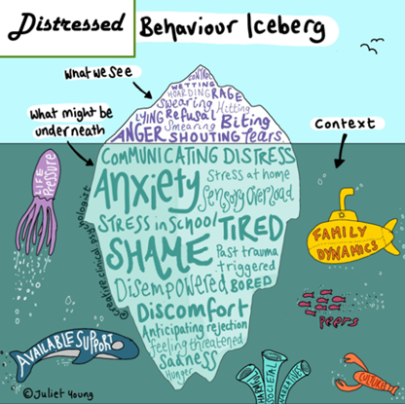
NEW IMAGE INCOMING!
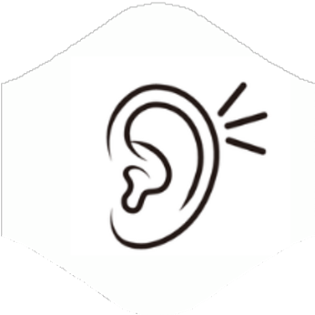
Sense of Hearing
The auditory system
Observed sensory based behaviours  Use a code such as S= School, P= Parent, C= Carer to show who has observed this sensory behaviour | Always | Often | Some times | Rarely | Never
Dislikes noisy places
Easily distracted and bothered by background noises
Cries/covers ears with loud or unexpected sounds
Asks/tells others to be quiet
Reacts to noise with a certain pitch/texture rather than volume
Becomes excited by noise
Can’t filter out noise and effects focus
Short attention span
Can hear sounds others are not aware of
Puts hands over ears
Difficulty listening in a group
May not consistently respond to their name
Prefers TV and music to be loud
Often doesn’t notice background noise
May appear oblivious to some sounds
Has difficulty locating a sound
Makes their own sound to increase alert level or drown other noise
Can be unaware of own voice volume
Needs to leave the environment when auditory system is over stimulated
May not respond to verbal prompts/cues
Often talks themselves through a task, aloud, and without realising this may distract others.

Strategies
- Quieter spaces e.g. to eat lunch, workstations, safe spaces/dark den
- Access to noise reducing resources such as ear defenders/loops
- Screening to reduce environmental sounds
- Staff awareness of acoustics- carpeted classrooms, curtains and blinds to minimise noise
- Preparation of specific noises if known
- Use of music through headphones (calming, arousing or white noise)
- Use name to gain attention
- Personalised visual cues and prompts e.g. to do list/writing frames, jigs
- Additional processing time – slower pace of speech & ‘chunking’ of instructions
- Over learning and repetition, asking students to repeat instructions back
- Use rhythm and beat to help memory
- Provide staggered transitions
- Offering choice of seating placement

Strategies to try

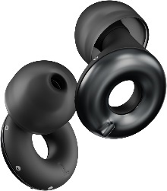
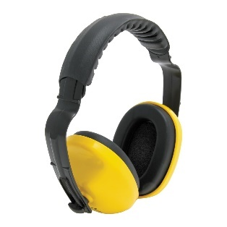
For the home
- Visual checklists to support memory
- Provide ear defenders/loops
- Prepare for specific noises if known
- Identify and label different sounds
- Use of name to gain attention
- Vary tone of voice, e.g. sing-song voice
Interventions
- Carpeted classrooms/chair legs
- Visual supports for noise levels
- I describe you draw…
- Sound Matching - Bingo
- Shaking sounds pg120- Bottles with different items that make different sounds when the bottle is shaken.
- Recording different sounds in the environment

Sense of Touch
The tactile system

Observed sensory based behaviours  Use a code such as S= School, P= Parent, C= Carer to show who has observed this sensory behaviour | Always | Often | Some times | Rarely | Never
Is agitated by seams in clothing, tags, or waistbands/ adjusts clothing
Has preferred items and types of clothing/fabrics
May find protective clothing uncomfortable or distressing
Avoids touch or physical contact
Avoids certain surfaces
Avoids messy play
Prefers to eat with fork/spoon and not finger foods
Avoids standing close to others/crowded situations e.g. sit in a circle
Finds it difficult to work in a defined/confined space with others
Can find holding writing or cutting equipment difficult
Startles easily when touched unexpectedly
Overreacts to minor injuries/doesn’t notice minor injuries
May prefer to be without clothes/barefoot
Doesn’t seem to notice messy hands or face or wipe runny nose
Touches everything including others- craving touch
Unaware of light touch e.g. being bumped
Unintentionally rough with other children
Difficulty with fine motor skills, e.g. ma only use finger tips rather than whole hand to manipulate objects
Does not recognise when shoes are on the wrong feet
Engages in self-stimulatory/ self-injurious behaviour
Seeks out deep pressure activities
Finds personal grooming extremely stressful e.g. hair brushing/ teeth brushing/ hair cutting

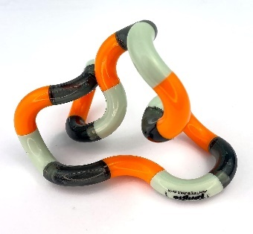
Interventions
- Access to daily Sensory Motor Circuits
- Therapy brushing (CYP led)
- Resistance exercises
- Social stories for personal space
- Messy play (messy play hierarchy)
- Deep pressure to the feet, massage or use of massage rollers
- Contrasting tactile experiences in learning e.g. sandpaper letters, shaving foam to draw
For the home
- Consider adaptive clothing e.g. removing tags, seamless socks/underwear
- Identify messy hands and face through using a mirror to see the mess so they can action cleaning up
- Raise awareness of their dress/shoes- what to look for and how to alter
- Cooking together, including preparation
- Use heavy/ weighted blanket (20mins)
- Snuggling into cushions
- Tangle spray and brushes for hair brushing
- For haircutting, try clippers rather than scissors and use of weighted shoulder wrap
- Teeth – finger brushes/non-flavoured toothpastes/timers to show ‘finished’

Strategies
- Textured tiles stuck under the desk (pupil preference)
- No pressure to take part in activities- initially allowing to watch and gradually increasing expectations to participate
- Peg at the end of the cloakroom, standing at the front, or back, of the line
- Consider seating and movement times to minimise being bumped into by others
- Necessary adjustments regarding uniform
- Use of deep pressure activities - to calm/soothe and regulate.
- Consider the use of tighter clothing (following guidelines for use)
- Remove shoes
- Use of hand fidgets
- Be mindful of left-handed learners sitting next to someone who is right-handed
- Provide clearly demarcated personal ‘bubble’ (space)
- Use of vibrating cushions, wobble cushions, wedges …
- Verbally gain learners attention, avoid light touch
- Ensure clear pathways around classrooms and school building
- Gentle squeezing of hands
- Allow students to wear gloves to reduce tactile input
Strategies to try

Sense of Sight
The visual system
Observed sensory based behaviours  Use a code such as S= School, P= Parent, C= Carer to show who has observed this sensory behaviour | Always | Often | Some times | Rarely | Never
Bothered by bright lights, sun
Dislikes visually busy places/environments
Avoids visually ‘busy’ games and toys
Avoidance/Prefers certain colours
Avoids eye contact
Prefers dim lighting/shades/dark areas
Rubs eyes a lot/bloodshot
May show signs of headaches from reading/writing tasks
Can find it difficult to see objects on a busy picture
Turns/tilts head or moves paper when reading and writing
Blinks very frequently/squints
Moves hands/fingers/objects in front of their eyes constantly
Struggles to focus on objects
Finds sustained focus on TV/computer screen difficult
Finds coloured overlays/paper helpful when reading and writing
Difficulty following a visual model/schedule
Enjoys visually busy tasks/games/action-packed TV shows
Too visually focused-doesn’t monitor the periphery
Loves shiny/spinning/ moving objects
Difficulty with hand-eye co-ordination tasks
Difficulty distinguishing between similar letters/shapes
Difficulty with visual from left to right/may lose their place
Difficulty transferring information from the board
Focuses on details and misses the bigger picture/concept
Walks into people/objects as if they were not there
Struggles to judge distances so may bump into furniture
Difficulty matching and sorting objects
Enjoys watching repetitive movements
Strategies

- Reduce clutter on the table and around focal points in the classroom (e.g. IWB)
- Visual Tracking activities, e.g. cut out window to read through
- No pressure for eye contact
- Visual markers for seating, routes, where to stand, resources
- Chunking work into visual sections
- Awareness of visual tracking e.g. board to desk, left to right
- Writing slopes
- Coloured overlays/coloured paper for reading and writing
- Visual calmers
- Seating arrangements, thinking about natural light, strip light, blinds, distance from the board
- Quiet safe space/screening- low arousal/dark den
- Use of clear pencil case and labelled containers
- Necessary adjustments for sunglasses, peaked caps, hoods, tinted glasses
- Use of multimedia, e.g. cartoons, animations, videos, pictures

Strategies to try

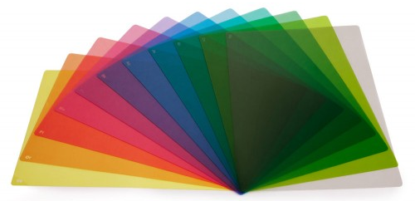
Interventions

- Kim’s game pg 114- Lay objects on a tray, allow the child 1 minute to look, cover and give the child 5 minutes to write/draw what they saw.
- Guess Who!
- Magnified images pg 118- take several pictures of an object at different magnifications, show the child an image starting with most magnified and ask the child to determine what it is
- Visual breaks, turning off lights/dimming, closing eyes for 60s
- Visual discrimination activities e.g. spot the difference

Ideas for the home

- Night light for the dark
- Safe space, e.g. homemade den, under the bed/blanket
- Respect colour preferences e.g. for clothing/food
- Use puzzles and colouring patterns
- Kaleidoscopes and lava lamps
- Laundry Fun! – sorting washing

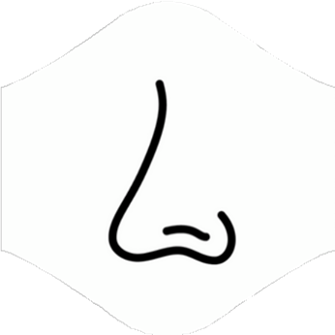
Sense of Smell
The olfactory system

Observed sensory based behaviours  Use a code such as S= School, P= Parent, C= Carer to show who has observed this sensory behaviour | Always | Often | Some  times | Rarely | Never
Talks about smells a lot/notices odours others don’t
Becomes distressed by smells that others do not find offensive
Covers or plugs nose/avoids places with strong smells
Distracted by smell in the room and this impacts on their ability to focus
Avoids certain areas of the school or home
Refuses certain foods (see taste)
Becomes distressed at lunchtime/will avoid the school dinner hall
Complains of nausea at set times
Smells non-food objects and/or people
Prefers strong smells
Craves and actively seeks certain smells
Finds distinguishing between smells difficult
Does not appear to notice strong smells
Breathes through mouth instead of their nose
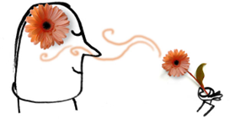
Strategies to try

For the home
- Hand massage with essential oil
- Use of a tissue or handkerchief with a preferred smell
- Home cooking opportunities

Strategies
- Use fragrant pens/colours
- Carrying handkerchief/ tissue with a smell they like (including aromatherapy)
- Allow access to alternative toilets
- Consider providing scratch and sniff stickers for alternative smells
- Increase the amount of ‘heavy’ type play as proprioception assists self-regulation
- Consider seating e.g. bin, window, door, others use of washing powders, perfume etc
- Provide clearly demarcated personal ‘bubble’ (space)
- Ensure the pupil can see the whole room from their seated position
- Staff refrain from wearing strong fragrances


Sense of Taste
The gustatory system

Observed sensory based behaviours  Use a code such as S= School, P= Parent, C= Carer to show who has observed this sensory behaviour | Always | Often | Some  times | Rarely | Never
Dislikes new foods
Hesitant to try new foods, even certain brands, flavours, and/or textures
Prefers a set texture to food e.g. dry, sloppy, crunchy, chewy
May have limited food preferences e.g. a ‘beige diet’
Gags easily
Prefers to eat only hot or cold foods
Complains about strongly floured tastes- spicy, salty, sweet, sour
Prefers food presented on a separate plate/food not to be touching
Finds tooth brushing distressing
Licks/tries to eat inedible objects- constantly seeking input through the mouth
Prefers strongly flavoured foods/craves intense flavours
Appears to ‘taste’ all foods as the same
Packs food into mouth before swallowing
Eats very quickly
Excessive drooling
Seeks sauces or condiments (e.g. tomato ketchup, salt) on meals


Strategies to try
Strategies
- Use visual cues for food
- Give a choice of foods
- Eating in an alternative space – quieter environments (reduction of social expectations)
- Deep pressure / firm touch before eating
- Allowing different food to be separate
- Allowing food to be eating in preferred order (to the norm, preferred food first)
- Encourage the use of a mirror after eating to build self-care, independence
- Provide soothing deep pressure/ weights prior to and during mealtimes
- Alternative/adaptive cutlery
- Provide safe oral sensory resources
- Listening to calming (background) music at meal times


For the home
- Help with food preparation and cooking
- Experiment with toothbrushes e.g. a baby toothbrush- softer bristles, vibrating toothbrush
- Alternative toothpaste- non flavoured/ non frothing
- Offer food you are eating to build familiarity
- Consider food textures – same/similar texture for same meal
- Ensure a safe food is always available
Interventions
- Experimental activities with food e.g. food based tuff trays adding in toys the child enjoys
- Explore temperature- frozen, cold, warm (visual cues of what to do e.g. wait, blow, etc. Cold food first)
- Explore texture- crunchy, creamy, chewy, lumpy
- Exploring different oral actions:
  - Chewing- e.g. chew toys, chewy bracelets, chewy foods
  - Blowing- e.g. bubbles, whistles
  - Sucking- e.g. through straws, sports bottles, different thickness of liquid
- Teach appropriate social expectations e.g. licking other people
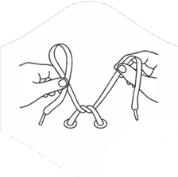
Early Developmental skills

These are sensory based tasks that require sensory integration.

Highlight the statements the CYP can do. At each reassessment phase, highlight additional skills gained.
Grasps objects
Eats food using a pinch grip to open and close, use cutlery
Holds crayon in fist grip
Mark makes independently
Draws circles/lines with controls
Uses finger pointing e.g. when looking at a book/ pictures / identifying shared focus
Traces / Overwrites numbers/ letters / shapes
Copies numbers / letter/ shapes
Snips with scissors/ cuts in a continuous movement
Able to hold paper and cut, turning corners
Threads independently
Turns door handles, screws and unscrews lids off jars
Stacks blocks
Fits objects into the right holes including posting games
Can do buttons / zips
Can complete a lacing card/ do shoelaces
Pours water/ sand from one container to another accurately
Holds pencil in tripod grip
Turns pages independently in a book
Squeeze, flatten, roll playdough
Screws and unscrews nuts and bolts (construction kits)
Deconstructs toys e.g. pull apart Lego
Throw a ball in the intended direction
Catch a ball (with 2 hands)
March to music and clap hands at the same time



Sensory Profile

Process overview

Positive





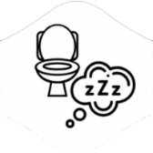
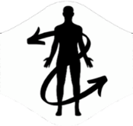
Select some new/different strategies or interventions to work with the sensory processing differences of the individual:
Provide opportunities for sensory preference experiences
Supports the CYP’s sensory challenges through necessary adaptations to the environment and expectations

Transfer the questionnaire information onto the 1 page profile – sensory preferences/challenges
School and Family work collaboratively to complete the Sensory Questionnaire in main resource
Obtain the Child / Young Person’s perspective on their sensory likes & dislikes, needs & challenges
This 1-page profile is a living document and should be reviewed regularly as part of the Graduated Approach, or if there is a significant change in behaviour/presentation. Strategies and interventions should be implemented consistently for a period of 4-6 weeks. Our research at WTT indicates that this time frame typically allows for observable impact.

