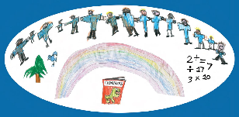



Positive

Sensory Profile

Guidance

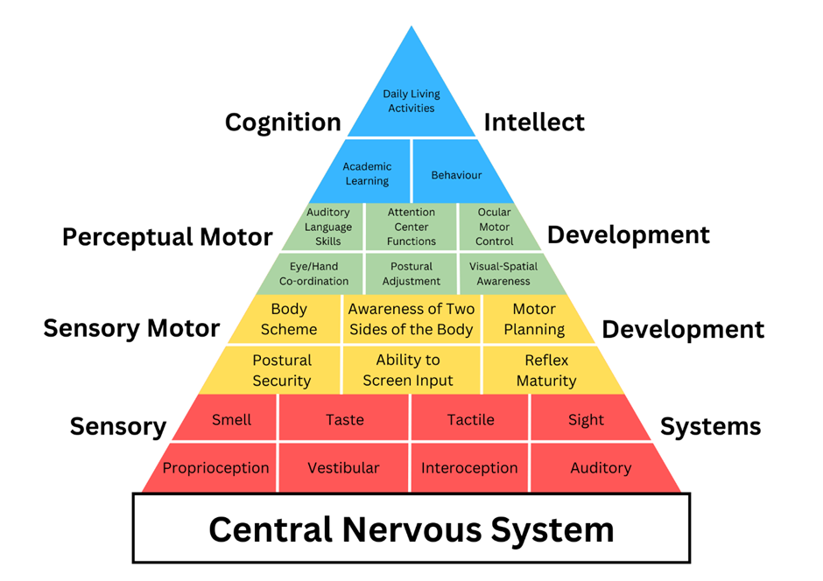

The Pyramid of Learning (Trott & Taylor)
The development and regulation of the sensory systems are the foundations necessary for attention, engagement, focus and learning

This resource is designed to enhance understanding of an individual’s unique sensory processing profile and how this impacts their daily life. We aim to:
- Enable the CYP to access different school environments & engage with learning more comfortably
- Increase self-awareness and teach self-regulation strategies to develop independence & autonomy
How to use this resource to create a
Positive Sensory Profile









Step 1- Gathering baseline information
SENSORY PREFERENCES:
These are the sensory sensations the CYP is choosing to engage with and/or seeking out more input.
These will be helping the individual to ‘feel good’, to feel calmer or better regulated.
SENSORY CHALLENGES:
This section collates the expectations and activities the CYP finds difficult to process.
These may cause confusion, increased anxiety, overwhelm, provoke physical discomfort/pain

Transfer those behaviours observed ‘always’ or ‘often’, and to a degree that impacts on day-to-day routine and activities of the Child/Young Person, to the 1-page profile format.
Please also reflect the Child/Young Persons perspective
Observing Sensory-based Behaviours
For each sensory-based behaviour described within the different sensory systems, please tick the column that represents the frequency with which this behaviour has been observed (for example, over the last month)
Use a code, such a S = school, P = parent, C = carer, to show who has observed this sensory behaviour response. Only complete the sections relevant to the individual.
Sensory responses and reactions may vary between home and school in frequency and intensity which is a valuable part of understanding the child and guiding the profiling process.

This process is most effective when school and home complete this resource together.
Obtain the child/young person’s perspective
Step 2- Selecting support strategies
Once the CYP’s sensory preferences and sensory challenges have been added to their 1-page profile, use the following process to identify support strategies.
Consider realistic strategies to support key sensory systems- start with just 2 or 3 (suggestions are provided in the resource).
You may wish to highlight those already in place.









REASONABLE ADJUSTMENTS
This section supports the CYP’s Sensory Challenges through the necessary adaptations that are needed to the environment and expectations, to enable the individual to access school, social demands and their learning more comfortably. These adjustments support the CYP to become more aware of their sensory differences, lessening anxiety and increasing independence.

POSITIVE SENSORY PROGRAMME:
Select proactive interventions and strategies that aim to replicate (where possible) the sensations identified in the Sensory Preference section on the 1-page profile. These activities will help promote ongoing regulation and support the development of self-regulation skills.

Use the chosen activities and strategies in conjunction with personalised visual supports identified to reduce anxiety.
Strategies and interventions should be used consistently for 4–6 weeks.

Strategies should be adapted to suit the environment, equipment available and individual preferences and challenges.
Please see WTT website for completed profile examples and additional resources

