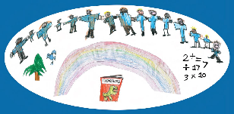



‘Listening to me’

Gaining

Children and Young People’s sensory voice

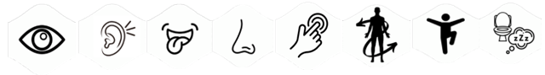

Listening to Me!
My sensory like and dislikes

Balance (vestibular)
What I like:

What I don’t like:

Body Awareness (proprioception)
What I like:

What I don’t like:

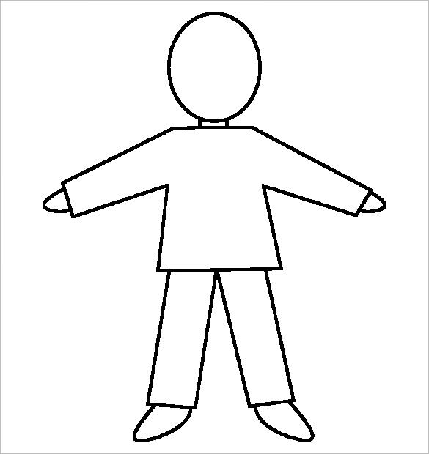
Hearing (auditory)
What I like:

What I don’t like:

Touch (tactile)
What I like:

What I don’t like:

Sight (visual)
What I like:

What I don’t like:

Smell (olfactory)
What I like:

What I don’t like:

Taste (gustatory)
What I like:

What I don’t like:

This format may be more suitable for younger children or those in the early stages of understanding & expressing their sensory experiences.
For pre-verbal CYP, you might like to add a photograph to show what the child likes doing

Sensory Questionnaire

Hello! This is a questionnaire to help us understand how you feel about certain sights, sounds, movements, smells and other sensory experiences in your everyday life. There are no right or wrong answers – everyone is different!
For most questions, choose the answer that feels right for you. If you would like to explain more, then please feel free to use the spaces provided below each section
Seeing things

When things change – like new routines or plans – then I feel …
Fine Not sure Not OK
Classroom lights are …
OK Not OK
Lights at home are …
OK Not OK
Flashing Lights are …
OK Not OK
I like colourful lights … like lights on toys
Yes No
I like shiny things and bright colours
Yes No
I like looking at patterns (like patterns and swirls)
Yes No
I get lost easily
Yes No
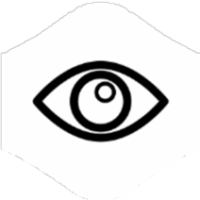
For anything else you want to tell us:

Moving around

I feel OK with heights, lifts and escalators
OK Not OK
I can catch a ball
Yes No
I like running and climbing
Yes No
I like riding a bike
Yes No
I can balance on one leg
Yes No
I like swings and trampolines
Yes No
I sometimes bump into people or things
Yes No

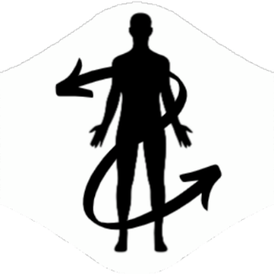
For anything else you want to tell us:

Smelling, Tasting and Touching

I like to smell, lick or touch things and people
Yes No
I know when I have hurt myself
Yes No
These are foods I like
________________________________________________
These are foods I don’t
________________________________________________
I like to put things in my mouth to chew or suck
Yes No
I like foods to look a certain way on my plate
Yes No
I like crunchy or chew foods
Yes No
I sometimes crawl under, or hide under heavy things
Yes No
I enjoy touching certain materials (like soft or bumpy things)
Yes No
These are smells I like
___________________________________________________
These are smells I don’t like
___________________________________________________

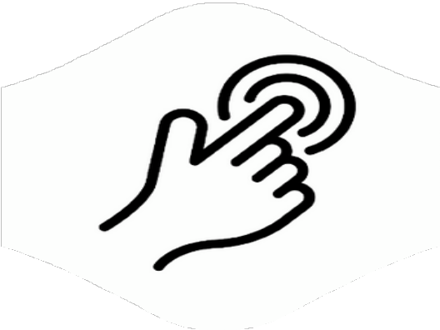
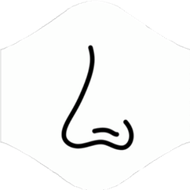
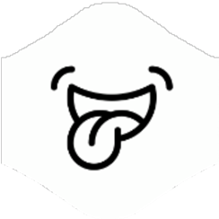
For anything else you want to tell us:

Hearing and Sounds

I cover my ears when I hear certain sounds
Yes No
I can hear things that other people don’t notice
Yes No
Sounds I like to listen to
________________________________________________________
Sounds that upset me
________________________________________________________
I like to bang things, or slam doors
Yes No
I like to make my own noise with my voice
Yes No

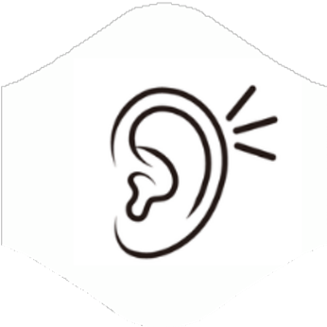
For anything else you want to tell us:

Feelings and other things

I like it when other people hug me
Yes No
I like giving hugs to other people
Yes No
I remember songs and rhymes easily
Yes No
I can remember places (and ‘routes’) really well
Yes No
I can remember lots of facts about things I like
Yes No
I find it easier to listen if I am not looking at the person who is talking
Yes No
I can tell someone how I am feeling (happy, sad, cross, worried, poorly)
Yes No
I can say why I am feeling these different emotions
Yes No
I know when I am hungry and thirsty
Yes No
I know when I am hot or cold
Yes No
I know when I need the toilet
Yes No
I like being in busy places (like shops, crowds, parties)
Yes No
In the classroom I like sitting …
At the Front / At the Back / I like to choose
I like working on my own
Yes No
I like working with other people
Yes No

Thank you!
This questionnaire helps adults understand your needs better so they can support you in ways that feel right for you. If there is anything else you’d like to say about how you experience things – at school, or at home, then please feel free to write it here:
______________________________________________________________________
________________________________________________________________________
________________________________________________________________________
________________________________________________________________________

Sensory Questionnaire

Hello! This is a questionnaire to help us understand how you feel about certain sights, sounds, movements, smells and other sensory experiences in your everyday life. There are no right or wrong answers – everyone is different!
For most questions, choose the answer that feels right for you. If you would like to explain more, then please feel free to use the spaces provided below each section
Changes and Understanding the World


- When things change (like plans and routines), I feel:
Totally OK
A bit unsure
Not OK
- I get lost easily in new places:
Yes
Sometimes
No
- I can remember routes and places really well:
Yes
Sometimes
No
- I can memorise lots of information about things I’m really into:
Yes
Sometimes
No
For anything else you want to tell us: e.g. places you like to go, routes you like to take

Sights and Visuals

- Classroom lights are:
OK
Not OK
- Lights at home are:
OK
Not OK
- Flashing light (e.g. party light or alarms) are:
OK
Not OK
- I like coloured lights (for example on videos, decorations, in my room)
Yes
No
- Shiny objects or bright colours are:
OK
Not OK
- I like looking at different patterns (like swirls, brick walls, stripes)
Yes
No
- Sunlight is too bright
Yes
No
- My favourite colour is.. I dislike the colour…
______________________ ______________________

For anything else you want to tell us: e.g. any patterns you like/dislike, computer games, videos

Sounds & Hearing

- Crowded and noisy places feel:
OK
Not OK
- I cover my ears when I hear certain sounds:
Yes
Sometimes
No
- I can hear sounds other people don’t seem to notice:
Yes
Sometimes
No
- Some sounds upset me (please say which ones, if you want to):
__________________________________________

- I like to bang objects or doors:
Yes
Sometimes
No
- I’m attracted to certain sounds or noises:
Yes
No
- It’s easier for me to listen when I’m not looking at the person talking:
Yes
No
For anything else you want to tell us: e.g. noises you like, the type of music you enjoy

Touch and Body Awareness

- I like being hugged by other people:
Yes
No
- I like a hug, if I choose them:
Yes
No
- I like to smell, lick or touch objects and/or people:
Yes
Sometimes
No
- I like feeling certain fabrics and surfaces (e.g. soft things, rough surfaces):
Yes
No
- Sometimes I crawl under, or squeeze between heavy objects:
Yes
No
- I know when I have hurt myself:
Yes
No
For anything else you want to tell us: e.g. any objects you prefer, textures you like or dislike

Smell and Taste

- There are smells I really don’t like (you can say which, if you want):
____________________________________________________
- There are foods I don’t like (please list any, if you want):
____________________________________________________

- I like putting things in my mouth to suck or chew (e.g. pens, toys):
Yes
No
- I like foods to be presented in a certain way on my plate:
Yes
No
- I like crunchy or chewy foods best:
Yes
No
For anything else you want to tell us: e.g any perfume/aftershave you like or dislike

Movement and Balance

- I’m OK with things like heights, lifts and escalators:
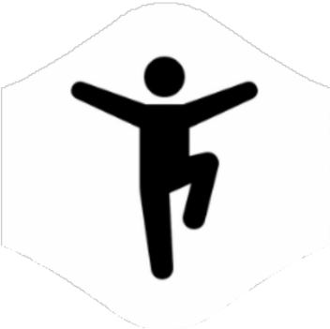
Yes
No
- I can catch a ball:
Yes
No
- I can be quite clumsy ( bump into things or people):
Yes
Sometimes
No
- I like running and climbing:
Yes
No
- I like riding a bike:
Yes
No
- I can balance on one leg:
Yes
No
- I like playing on swings and trampolines:
Yes
No
For anything else you want to tell us: e.g. any activities you like to do in your spare time

Learning and Social

- I prefer to sit:
At the front of the class/group
In the middle
At the back
It depends – I need to decide on the day
- I like to work on my own:
Yes
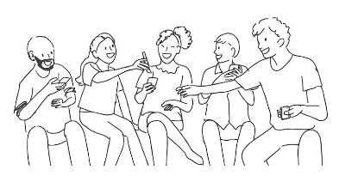
Sometimes
No
- I like to work with a partner:
Yes
Sometimes
No
- I like to work in a group:
Yes
Sometimes
No
- I have a good memory for songs/lyrics/raps:
Yes
No
For anything else you want to tell us: e.g. things you like to do with friends, songs you enjoy or dislike

Thank you!
This questionnaire helps adults understand your needs better so they can support you in ways that feel right for you. If there is anything else you’d like to say about how you experience things – at school, or at home, then please feel free to write it here:
______________________________________________________________________
________________________________________________________________________
________________________________________________________________________
________________________________________________________________________

