For further information about sensory circuits, or using a sensory circuit approach in school, please contact your WTT teacher. Staff training is available.
An introduction to Sensory Circuits
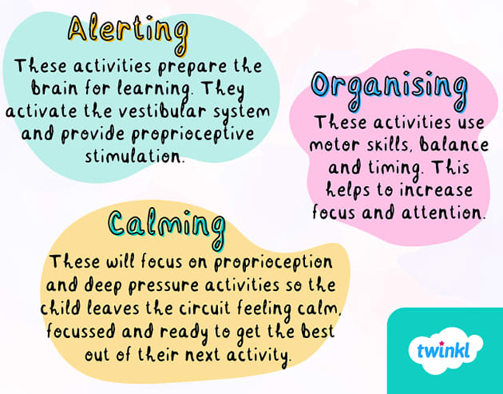
Sensory Circuits
A sensory circuit is a sensory processing intervention involving a sequence of physical activities—alerting, organizing, and calming—tailored to an individual's Positive Sensory Profile to achieve optimal regulation for learning.
The circuit should be active, physical and fun - something that the Children & Young People enjoy doing.

Sensory Circuits – ideas for each phase
Select one or two activities from each box, moving from left to right

  Alerting | 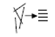  Organising |   Calming
Jogging on the spot  Star jumps  Spinning  Bouncing  Hula Hoop | Stepping Stones  Balance obstacle course  Throwing beanbags into hoops/baskets  Throwing and catching a ball  Simon Says | Wrapped in a blanket  Gentle, rhythmic rolling over a gym ball  Pulling or Pushing  Wall pushes  Planking

Many more ideas available online or on WTT’s website
Useful film clips to further explain and show sensory circuits in action
https://www.youtube.com/watch?v=4EpBSD3dJnM
https://youtu.be/6mLslef-HqI

