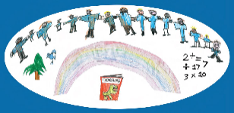



Positive

Sensory Profile

Strategy pack

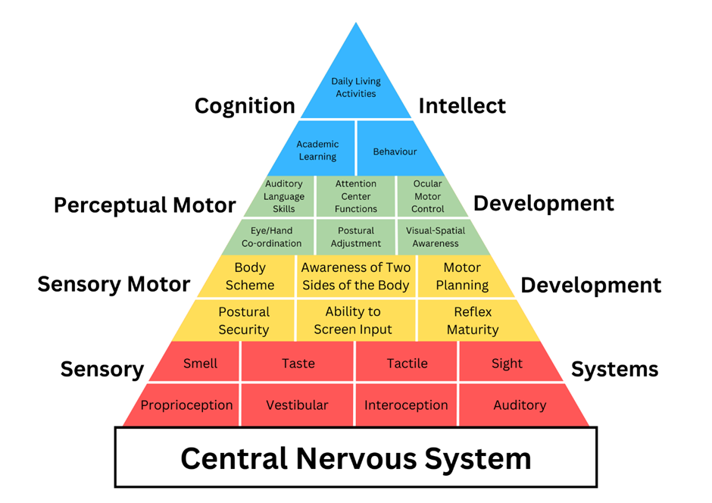

The Pyramid of Learning (Trott & Taylor)
The development and regulation of the sensory systems are the foundations necessary for attention, engagement, focus and learning


Positive Sensory profile for: Date:


Sensory Preferences:

Resources:

Positive Sensory Programme:

Target Priorities:

Sensory Challenges:

Reasonable adjustments:

Any other information:

This 1-page profile is a living document and should be reviewed regularly as part of the Graduated Approach, or if there is a significant change in behaviour/presentation. Strategies and interventions should be implemented consistently for a period of 4-6 weeks. Our research at WTT indicates that this time frame typically allows for observable impact.

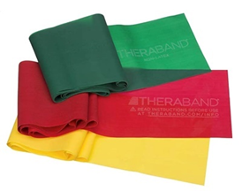
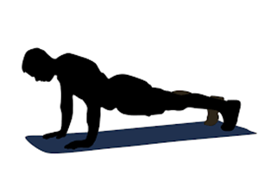
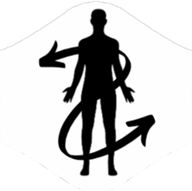
For the home
- Accessing soft play
- Tighter fitting clothing
- Weighted blankets (time limited)
- Provide access to crunchy/chewy foods/vibrating toothbrush
- ‘Hot dog game’- CYP lays on stomach, arms legs and back rubbed then snuggled tightly in a blanket
- Swimming
- Carry a weighted rucksack- calming
- Chewy snacks
Interventions
- Access to daily sensory motor activities
- Access to gym ball for additional rhythmical input
- Heavy work – deep pressure (for some students, every 2hrs)
- Yoga to stretch and relax muscles
- Teaching self-deep pressure techniques (self-joint compressions)
- Floating balloon games
- Beanbag target practice
- Playdoh
Strategies
- Drink from a water bottle e.g. with a straw
- Removal of shoes/Barefoot play and when necessary
- Hand exercises before handwriting
- Weighted supports (time limited), e.g. blankets, lap pads, vests, wrists/ankle weights, pencils/pens
- Weighted toys (can also be used during sustained periods of seating)
- Provide a range of regulating resources e.g. items to squeeze, stretch, twist, bite or chew
- Velcro strip stuck under the desk to rub
- Alternative seating- Hokki stool, Zuma chair, wiggle/wobble cushions, gym ball
- Movement/sensory breaks
  - Heavy muscles work e.g. carrying, pushing and pulling, climbing, squeezing/hugging activities e.g. wrap in blanket, self-hug, rolling
  - Resistance activities e.g. Therabands
- Allow additional toilet breaks and/or switching seats
Strategies to try

Strategies
- For a hyper-sensitive vestibular system limit unnecessary movement, allow additional time to move around, transitions and avoid activities where feet are off the ground
- Movement/sensory breaks – involving balancing’
  - Activities involving moving the head from side to side; turning, rotating, spinning, skipping, rocking, being upside down, rolling and tumbling
  - Activities involving moving the head up and down; jumping/bouncing, gym ball, star jumps, trampoline
- Alternative seating- Hokki stool, Zuma chair, wiggle/wobble cushions, gym ball, standing desk
- Allow the young person to maintain the position they are safe and regulated in, to complete adult led expectations (e.g. standing while working)
- Limited number of children or additional space for CYP during PE activities
- During PE consider alternatives to tumbling, running and jumping activities
- Allow CYP to hold on during balance activities
- When seated in the classroom, encourage feet to be placed on the ground
- Allow CYP to switch seats if/when needed
Strategies to try

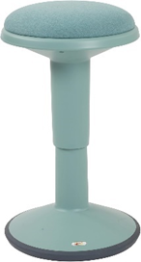
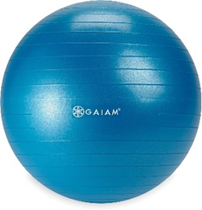
Intervention
- Access to daily sensory circuits – to include use of monkey bars / trim trail / ‘log rolling’
- Yoga to stretch and relax muscles
- Scooter boards to navigate obstacles
For the home
- Wobble board to develop core stability
- Activities involving moving the head from side to side/up and down; turning, rotating, spinning, skipping, rocking, being upside down, rolling and tumbling, jumping (trampoline/bed), swinging, dancing to music, play park
- For motion/travel sickness gradually increase length of journey
- Extra-curricular gymnastics
- Use of stairs rather than escalators
Ideas to support interoceptive differences
- Teaching clear routines for self-care and independence tasks (visually supported)
- Labelling physical signs/e.g. ‘I can see that you are hot because…’
- Encourage the CYP focus on their own body to identify clues to different emotions
- Personalised visual cues and prompts e.g. emotions, schedules and instructions
- Use proprioceptive and vestibular strategies to facilitate a calm/alert state
- Mindfulness and relaxation activities incorporating deep breathing – e.g. Yoga
- Use proprioceptive and vestibular support strategies to assist calm/alert state
- Providing resources and books related to emotions and feelings
- Where appropriate, support CYP to use personalised scaling to communicate & self-regulate

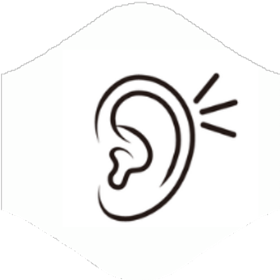
Strategies
- Quieter spaces e.g. to eat lunch, workstations, safe spaces/dark den
- Access to noise reducing resources such as ear defenders/loops
- Screening to reduce environmental sounds
- Staff awareness of acoustics- carpeted classrooms, curtains and blinds to minimise noise
- Preparation of specific noises if known
- Use of music through headphones (calming, arousing or white noise)
- Use name to gain attention
- Personalised visual cues and prompts e.g. to do list/writing frames, jigs
- Additional processing time – slower pace of speech & ‘chunking’ of instructions
- Over learning and repetition, asking students to repeat instructions back
- Use rhythm and beat to help memory
- Provide staggered transitions
- Offering choice of seating placement

Strategies to try

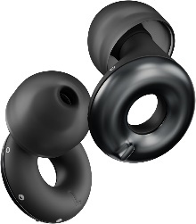
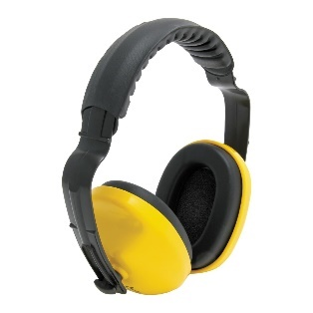
For the home
- Visual checklists to support memory
- Provide ear defenders/loops
- Prepare for specific noises if known
- Identify and label different sounds
- Use of name to gain attention
- Vary tone of voice, e.g. sing-song voice
Interventions
- Carpeted classrooms/chair legs
- Visual supports for noise levels
- I describe you draw…
- Sound Matching - Bingo
- Shaking sounds pg120- Bottles with different items that make different sounds when the bottle is shaken.
- Recording different sounds in the environment
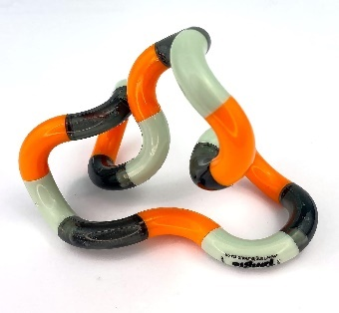

Interventions
- Access to daily Sensory Motor Circuits
- Therapy brushing (CYP led)
- Resistance exercises
- Social stories for personal space
- Messy play (messy play hierarchy)
- Deep pressure to the feet, massage or use of massage rollers
- Contrasting tactile experiences in learning e.g. sandpaper letters, shaving foam to draw
For the home
- Consider adaptive clothing e.g. removing tags, seamless socks/underwear
- Identify messy hands and face through using a mirror to see the mess so they can action cleaning up
- Raise awareness of their dress/shoes- what to look for and how to alter
- Cooking together, including preparation
- Use heavy/ weighted blanket (20mins)
- Snuggling into cushions
- Tangle spray and brushes for hair brushing
- For haircutting, try clippers rather than scissors and use of weighted shoulder wrap
- Teeth – finger brushes/non-flavoured toothpastes/timers to show ‘finished’

Strategies
- Textured tiles stuck under the desk (pupil preference)
- No pressure to take part in activities- initially allowing to watch and gradually increasing expectations to participate
- Peg at the end of the cloakroom, standing at the front, or back, of the line
- Consider seating and movement times to minimise being bumped into by others
- Necessary adjustments regarding uniform
- Use of deep pressure activities - to calm/soothe and regulate.
- Consider the use of tighter clothing (following guidelines for use)
- Remove shoes
- Use of hand fidgets
- Be mindful of left-handed learners sitting next to someone who is right-handed
- Provide clearly demarcated personal ‘bubble’ (space)
- Use of vibrating cushions, wobble cushions, wedges …
- Verbally gain learners attention, avoid light touch
- Ensure clear pathways around classrooms and school building
- Gentle squeezing of hands
- Allow students to wear gloves to reduce tactile input
Strategies to try

Strategies

- Reduce clutter on the table and around focal points in the classroom (e.g. IWB)
- Visual Tracking activities, e.g. cut out window to read through
- No pressure for eye contact
- Visual markers for seating, routes, where to stand, resources
- Chunking work into visual sections
- Awareness of visual tracking e.g. board to desk, left to right
- Writing slopes
- Coloured overlays/coloured paper for reading and writing
- Visual calmers
- Seating arrangements, thinking about natural light, strip light, blinds, distance from the board
- Quiet safe space/screening- low arousal/dark den
- Use of clear pencil case and labelled containers
- Necessary adjustments for sunglasses, peaked caps, hoods, tinted glasses
- Use of multimedia, e.g. cartoons, animations, videos, pictures

Strategies to try

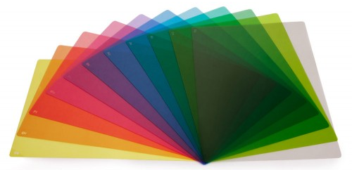
Interventions

- Kim’s game pg 114- Lay objects on a tray, allow the child 1 minute to look, cover and give the child 5 minutes to write/draw what they saw.
- Guess Who!
- Magnified images pg 118- take several pictures of an object at different magnifications, show the child an image starting with most magnified and ask the child to determine what it is
- Visual breaks, turning off lights/dimming, closing eyes for 60s
- Visual discrimination activities e.g. spot the difference

Ideas for the home

- Night light for the dark
- Safe space, e.g. homemade den, under the bed/blanket
- Respect colour preferences e.g. for clothing/food
- Use puzzles and colouring patterns
- Kaleidoscopes and lava lamps
- Laundry Fun! – sorting washing

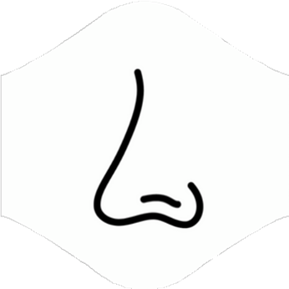
Strategies to try
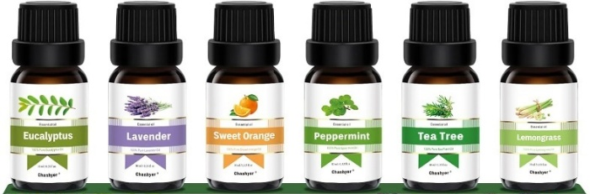
For the home
- Hand massage with essential oil
- Use of a tissue or handkerchief with a preferred smell
- Home cooking opportunities

Strategies
- Use fragrant pens/colours
- Carrying handkerchief/ tissue with a smell they like (including aromatherapy)
- Allow access to alternative toilets
- Consider providing scratch and sniff stickers for alternative smells
- Increase the amount of ‘heavy’ type play as proprioception assists self-regulation
- Consider seating e.g. bin, window, door, others use of washing powders, perfume etc
- Provide clearly demarcated personal ‘bubble’ (space)
- Ensure the pupil can see the whole room from their seated position
- Staff refrain from wearing strong fragrances


Strategies to try
Strategies
- Use visual cues for food
- Give a choice of foods
- Eating in an alternative space – quieter environments (reduction of social expectations)
- Deep pressure / firm touch before eating
- Allowing different food to be separate
- Allowing food to be eating in preferred order (to the norm, preferred food first)
- Encourage the use of a mirror after eating to build self-care, independence
- Provide soothing deep pressure/ weights prior to and during mealtimes
- Alternative/adaptive cutlery
- Provide safe oral sensory resources
- Listening to calming (background) music at meal times


For the home
- Help with food preparation and cooking
- Experiment with toothbrushes e.g. a baby toothbrush- softer bristles, vibrating toothbrush
- Alternative toothpaste- non flavoured/ non frothing
- Offer food you are eating to build familiarity
- Consider food textures – same/similar texture for same meal
- Ensure a safe food is always available
Interventions
- Experimental activities with food e.g. food based tuff trays adding in toys the child enjoys
- Explore temperature- frozen, cold, warm (visual cues of what to do e.g. wait, blow, etc. Cold food first)
- Explore texture- crunchy, creamy, chewy, lumpy
- Exploring different oral actions:
  - Chewing- e.g. chew toys, chewy bracelets, chewy foods
  - Blowing- e.g. bubbles, whistles
  - Sucking- e.g. through straws, sports bottles, different thickness of liquid
- Teach appropriate social expectations e.g. licking other people


Sensory Profile

Process overview

Positive





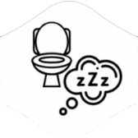

Select some new/different strategies or interventions to work with the sensory processing differences of the individual:
Provide opportunities for sensory preference experiences
Supports the CYP’s sensory challenges through necessary adaptations to the environment and expectations

Transfer the questionnaire information onto the 1 page profile – sensory preferences/challenges
School and Family work collaboratively to complete the Sensory Questionnaire in main resource
Obtain the Child / Young Person’s perspective on their sensory likes & dislikes, needs & challenges
This 1-page profile is a living document and should be reviewed regularly as part of the Graduated Approach, or if there is a significant change in behaviour/presentation. Strategies and interventions should be implemented consistently for a period of 4-6 weeks. Our research at WTT indicates that this time frame typically allows for observable impact.

