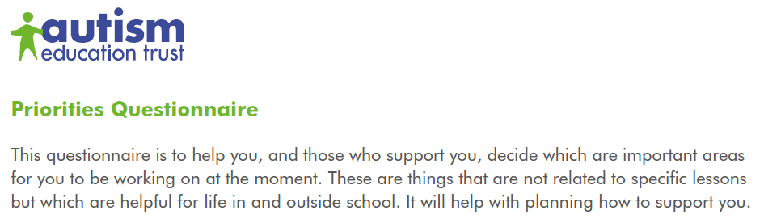
Name : _____________________________________ Date: ____________________

Things I like (including interests / hobbies) :

My strengths and skills (things I’m good at) :

Things I find difficult :

My hopes for the future :

Look at the following list. Fill in the chart to show which areas you think are important to work on and have support with this year. It might help to discuss them with someone you know well.
Areas to work on - | Yes | Maybe | No
Communicating my needs and ideas
Listening to people
Understanding what people mean
Having conversations
Being with other people
Getting on with adults who support me
Making friends
Working in a group
Understanding my sensory needs
Managing my sensory needs
Helping others understand my sensory needs
Coping with change
Moving to another activity, place (transitions)
Joining in with things that aren’t my special interests
Working out what to do in different situations (problem solving)
Understanding my feelings and behaviour
Managing my feelings and behaviour
Understanding others’ feelings and behaviour
Being confident
Joining in with different kinds of activities / subjects
Working by myself
Organising myself and my time
Understanding and following rules and expectations
Keeping myself healthy
Mananging my personal care
Understanding about puberty and becoming an adult
Being more independent with tasks such as cooking, shopping, managing money, cleaning etc
Keeping myself safe
Travelling by myself
Using my leisure time

